Technical guidance for the built environment

Accessible and Inclusive Tourism Toolkit for Businesses

Introduction

The objective of this resource is to provide readers, mostly of SME tourism businesses, with an understanding of the key technical accessibility and inclusive design guidance that should be applied to new-build, refurbishment, conversion, and adaptation projects as far as practicable within any existing site or building constraints.

Please note: This document does not replicate all possible standards but is designed as a helpful guide to the key criteria expected. Many projects will be subject to both Planning and Building Regulation consents. Planning policy varies across England and should be considered at the outset of every project. It should be noted that new buildings within the Greater London Area fall under the ‘London Plan’ and are expected to fully meet the BS8300 Codes of Practice standards.

Contents
Technical guidance for the built environment 1
Accessible and Inclusive Tourism Toolkit for Businesses 1
Introduction 1
Contents 1
How to use this technical appendix 3
General technical guidance 6
Booking and pre-arrival 7
Arriving by vehicle 7
Wayfinding and signage 11
Pedestrian approach 12
Within the venue 17
Operations and management 26
Accommodation 29
Booking and pre-arrival 29
On arrival 30
Within the accommodation venue 30
Bedrooms 31
Bathrooms (in addition to the general guidance) 35
Kitchens (applies to all kitchen, servery and tea making facilities as appropriate) 38
Holiday parks 41
Operations and management 43
Visitor attractions 43
Booking and pre-arrival 43
On arrival 44
Within the attraction venue 45
Operations and management 49
Food and beverage businesses 50
Booking and pre-arrival 51
On arrival 51
Within the food and beverage venue 52
Operations and management 54
Business events venues 54
Booking and pre-arrival 54
On arrival 55
Within the events venue 56
Operations and management 60
Technical diagrams showing key measurements 61
Accessible parking bay dimensions 61
Clear widths required for different users 62
Accessible reach ranges 63
Accessible counter dimensions 64
Accessible seating dimensions 65
Lateral transfer space required for a wheelchair user 66
Elements within an ambulant cubicle 67
Accessible toilet dimensions 68
Appendix: Glossary of terms 69

How to use this technical appendix
This technical appendix has been divided into five sections to promote ease of use. The ‘general guidance’ section covers everything that tourism businesses, no matter the type, should consider in terms of accessible and inclusive design, from accessible parking to stair, ramp and lift design and the availability of accessible toilets and induction loops. The content then covers more specific tourism business types and venues - accommodation, attractions, food and beverage and business events venues - and provides streamlined technical guidance relating to these. You can also find diagrams showing key measurements in context at the end of this guidance.

In a bid to include the vital considerations of both customer and staff experiences, whilst ensuring that this technical appendix remains as concise and usable as possible, the below indicators have been created and added to all section tables:

Who does it help? | Key code | Description
Customers only | C | These are elements that only affect the customer experience within a tourism business.
Customers and staff members | CS | These are elements that affect both the customer and staff member experience within a tourism business.
Staff members only | S | These are elements that only affect the staff member experience within a tourism business.

As with any content created within the arena of access and inclusion, it is impossible to comment on each singular impairment, and its effect on individual customers and staff members. What is of real importance is that the impairment is never the focus; readers of this guidance should not be expected to have in-depth knowledge regarding medical conditions. Instead, they should use this document and the accompanying practical toolkit to learn about access requirements - and barriers to access - that may currently exist within their businesses, and how these can be improved through good design and an inclusive welcome.

Whilst all impairment groups should be given equal priority, there are certain instances where the needs of one impairment group may clash with another. For example, audio description for those with visual impairments may add confusion to or overstimulate the experience for those who have hearing loss or are autistic. Similarly, whilst certain colours or equipment may be distracting to some, they are necessary for others to be able to engage in their tourism experience or working day without disorientation. Where these juxtapositions in needs exist, this appendix lists the one most vital to enabling access and maintaining safety. Experts in their field with lived experience should also be consulted frequently prior to the implementation of any access and inclusion processes and equipment.

The recommendations in this technical appendix are based on the principles of inclusive design, existing accessibility legislation and good practice guidance. The following documentation has been reviewed in the creation of this appendix:

- The Equality Act 2010 (which has subsumed The Disability Discrimination Acts 1995 & 2005, & The Special Education Needs and Disabilities Act 2001)
- Building Regulations Approved Document M, Access to and Use of Buildings, Volume 2: Buildings other than Dwellings, 2015
- Building Regulations Approved Document B, Fire Safety, Volume 2: Buildings other than Dwellings, 2019
- BS8300-1: 2018 Design of an accessible and inclusive built environment Part 1: External environment - Code of practice
- BS8300-2: 2018 Design of an accessible and inclusive built environment Part 2: Buildings - Code of practice
- BS9999:2017 Code of practice - Fire safety in the design, management and use of buildings
- BS EN 81-70:2021+A1:2022, Safety rules for the construction and installation of lifts — Particular applications for passenger and goods passenger lift, Part 70: Accessibility to lifts for persons including persons with disability
- Department for Transport, Inclusive Mobility - A Guide to Best Practice on Access to Pedestrian and Transport Infrastructure, 2021
- London Legacy Development Corporation, Inclusive Design Standards, 2019
- The Sign Design Guide, A Guide to Inclusive Signage, 2000 (an updated version is due to be released soon)
- BSI 2022: PAS 6463 Design for the Mind - Neurodiversity and the Built Environment
- BSI 2022: PAS 1899 Electric Vehicles - Accessible Charging - Specification
- Historic England, Easy Access to Historic Buildings, 2015.
- Sport England, Accessible Sports Facilities, 2010 (due to be updated shortly)
- Paths for All, Outdoor Accessibility Guidance: Supporting Inclusive Outdoor Access in the UK, 2023
- Changing Places: The Practical Guide, 2021 update
- Inclusive Hotels Network, Access to Hotels for People with Hearing Loss, 2017
- Inclusive Hotels Network, The Use of Hoists in Guest Accommodation, 2018

Please note that, aside from BS8300, parts 1 and 2, BS9999 and BS EN 81-70, all documents listed above are free to access. Should you have an architect, accessibility consultant or wider design team onboard as part of your new build, refurbishment or upgrade process, it is strongly recommended that they also have access to the paid-for British Standards.

The above list is valid at the time of creating this appendix (November 2023). It is important that designers of new build developments always check against the latest building regulations, British Standards and local planning policy. Changes in Building Regulations are not applied retrospectively to an existing building but may be triggered in some circumstances, for example for some ‘Change of Use’ classifications and major refurbishments. Consultation with a building control professional is always recommended.

General technical guidance
If you are undergoing, or about to start, work on your business that will change the physical make-up of your venue, there are some general principles that should be followed to ensure that your customers can experience an accessible environment. These mainly relate to the requirements that your customers might have, regardless of whether they identify as disabled. They should, for example, be able to:
- access and use your website;
- be able to park in an accessible space at your venue or know where they can find nearby accessible parking;
- experience barrier-free entrances, exits and dwell spaces;
- use toilet facilities safely and with dignity;
- and be able to utilise inclusively designed equipment to aid with successful communication.
These things are not always possible to implement in particularly small or historic venues, or within businesses where time, budget and resources are minimal. This general section provides guidance for tourism businesses at times where best practice change is possible. These elements apply to all business types and are not repeated in individual business sections of this document.

Booking and pre-arrival

Item | Technical guidance | Who does it help?
Digital accessibility | When commissioning a new website or upgrade, ensure web designers are familiar with and adhere to the latest Web Content Accessibility Guidelines (WCAG). Please see section 6 of the accompanying toolkit for further details. | C
Accessibility Guides | Accessibility information, in the form of a detailed guide, should be available on the websites of all tourism venues and easily found from the home page. Please see section 6 of the accompanying toolkit for further details. | C

Arriving by vehicle

Item | Technical guidance | Who does it help?
Accessible parking provision | For tourism venues open to the general public, a minimum of 6% of the total car park capacity should consist of designated accessible parking bays. This should be in addition to any accessible parking bays provided to meet the needs of staff members. Accessible bays should be positioned together to provide proximity, safety and convenience for users, and signposted for drivers from the main site entrance. The bays should be placed on firm and level ground, and within 50 metres of the venue entrance. Any undercover parking should have a minimum clearance height of 2600mm to allow access for larger Wheelchair Accessible Vehicles (WAVs). All parking should be provided on level ground, with a gradient not exceeding 1:60, and step-free onward access should be available from all accessible parking bays and pick up/drop-off points. | C
Accessible bay dimensions - off-street | All off-street accessible parking bays should be well signed with the International Symbol of Accessibility and be at least 2400mm wide x 4800mm long. A minimum 1200mm hatched zone should be present at the rear and sides of all accessible spaces, to aid safe access and egress. For further information, please refer to the Department for Transport’s ‘Inclusive Mobility’ document. | CS
Enlarged parking spaces | Aim to provide some wider or enlarged parking bays that are 3600mm wide x 6000mm long to future-proof the need for additional designated spaces and provide access to those with larger vehicles, side and rear lifts. | CS
Accessible bay dimensions - on-street | On-street accessible parking bays that are parallel to a kerb should be at least 2700mm wide x 6600mm long and have signage and markings that comply with the Traffic Signs Regulations and General Directions (TSRGD), 2016. For further information, please refer to the Department for Transport’s ‘Inclusive Mobility’ document. | CS
Staff car parking | Ensure that an accessible parking space is available and reserved for every member of staff that requires one. This should be in addition to the provision of accessible spaces for public use. | S
Pick up/drop off points | Any pick up or drop off points provided should be as close as possible to the venue entrance, ideally be under cover and should be a minimum of 3600mm wide x 9000mm long to allow access by larger WAVs. Whilst step-free access should be provided to most pick up/drop off bays, a raised kerb can be beneficial for vehicles, such as taxis, with shorter ramps to ensure deployment and use at a safe angle. | CS
Electric vehicle charging | When providing Electric Vehicle Charging Points (EVCs) for customers, the equivalent number of accessible EVCs should be provided for designated accessible spaces.  In terms of design, the centreline of the chargepoint outlet and charging cable connector should be positioned between 800-950mm from floor level; the top of any visual interface used should be positioned at a maximum height of 1300mm; the top of any buttons or touch screen elements should be positioned at a maximum height of 1200mm; and the bottom edge of the payment terminal should be positioned between 800-1000mm from floor level. Please refer to PAS 1899:2022 for further information. | CS
Accessible cycle parking | Where cycle stands are provided, a minimum of 5% of these should be capable of accommodating larger, adapted cycles. Where possible, adapted cycle spaces should be placed on the end of cycle parking rows, and be 3000mm long x 3000mm wide to promote safe parking and provide adequate access aisle space.  Where cycle stands are provided on-street, they should visually contrast with their environment and provide ground level detection not higher than 150mm above floor level in order to be identifiable by blind and partially sighted individuals. | CS
Ticket machine design | Where parking is free for blue badge holders, ticketing machines should still be designed to be accessible for disabled people who do not hold a blue badge. Induction loops should be available, and inclusively signed, for D/deaf users and those with hearing loss to communicate with added ease. Any ticketing machine announcements and/or instructions should be available in both audio and visual formats. Any actionable elements, such as coin slots and ticket retrieval buttons, should be between 750-1200mm above floor level on at least one ticket machine that is lowered for seated users. | CS
Ticket machine access | Access to all ticket machines should be step free, with space in front that is level and unobstructed. A minimum 2000mm x 2000mm space should be provided in front of all ticket machines for wheelchair users to turn, and to facilitate safe queuing. | CS
Two-way comms | If two-way communication is required to enter or exit the car park, or pay for a ticket, either a text number or video capabilities should be available to ensure D/deaf customers and staff, and people with speech impairments, receive equitable access. | CS

Wayfinding and signage

Item | Technical guidance | Who does it help?
Wayfinding and signage | Ensure that all routes to and within the property are clearly signposted with consistent, concise and contrasting text that is supported by directional arrows and, where appropriate, pictograms. Signs should be carefully located and non-reflective. They should take a ‘two sense’ wayfinding approach, not just relying on the use of one sense for users to identify and follow them effectively.  Wall mounted signs should be placed between 1400mm and 1700mm from finished floor level; signs suspended from the ceiling should provide a minimum headroom of 2300mm and be supplemented at eye level. Signs should not have sharp edges or details, or cause obstruction.  The use of light-coloured lettering, symbols and pictograms on a dark background is preferred, and the two colours should have a minimum difference in Light Reflectance Value (LRV) of 70 points. The signboard should also visually contrast with the background it is mounted on by a minimum of 30 LRV points. All signage text should be in a sans serif font, start with an upper case letter and continue with lower case letters.  Fire exits should be clearly defined, illuminated, and comply with the relevant building regulations. Any specific accessible routes should be signed with the International Symbol of Accessibility, and ‘way out’ signs should be displayed where the general exit differs from fire exit routes.  For further information on signage and wayfinding design principles, please refer to Sport England, Accessible and Inclusive Sports Facilities, 2023 – Part E, as well as statutory Health and Safety and fire signage requirements. | CS
Text and pictogram size | For long distance signs, character size should be a minimum of 150mm. This may relate to entrance signs, for example.  For medium range reading, which could relate to directional signage within venues, character size should be 50-100mm.  Where close reading is required, which could relate to in-room or exhibition information, character size should be15-25mm. Signage pictograms should be at least 100mm in height. | CS
Tactile and braille signage | Where possible and practicable, tactile and braille signage should also be available. This should be prioritised for safety and toilet door signage, with tactile signage available in sans serif font, and mounted between 1400mm and 1700mm in height for access by both standing and seated users. | CS

Pedestrian approach

Item | Technical guidance | Who does it help?
Access routes | Ensure all access routes are of the lowest gradient possible in the range of 1:60 to 1:20. Anything at a gradient of 1:20 or above is considered a ramp and should be designed as such. Where the route is steeper than 1:60 but not as steep as 1:20, it should have a level landing for each 500mm rise along the route. | CS
Dropped kerbs | Dropped kerbs should be provided where step-free access is required to and from a pavement, or via a crossing, for pedestrians, and should be placed logically to provide safe, convenient use without causing obstruction. Where dropped kerbs are required, the legal maximum steepness for these is 1:12, but a maximum gradient of 1:15 is more realistic for independent use and should be adhered to, where possible. Visually contrasting, tactile blister surfaces should be installed on all dropped kerbs along pedestrian routes. | CS
Route surfacing | Make sure all external and internal pedestrian routes are free from obstacles. Routes should have firm, well maintained surfaces with a maximum cross-fall of 1:50. | CS
Unobstructed routes | Ensure that all main access routes to and within the property have an unobstructed minimum clear width of 1800mm, and 2000mm where possible. This allows two wheelchair users to pass one another on the same route. Where route clear widths need to narrow around an obstruction, this should be to a minimum of 1200mm, and for no more than two metres at a time.  All routes should also be vertically unobstructed to a minimum of 2300mm. If cyclists are using the route, a minimum clearance of 2400mm is recommended.  Care should be taken to ensure trees, roots and overhanging branches do not obstruct routes and present a potential hazard. | CS
Graded routes and ramps | Where a level route is not possible, a gradient can be introduced to provide step free access. This should be as gentle as possible and for new buildings, the requirements set out in BS8300-1:2018 should be followed. A gradient of less than 1:20 is considered a slope and does not require handrails. A gradient steeper than 1:20 requires a slip resistant contrasting surface finish and handrails on both sides. Ensure that, where required, ramps are the lowest possible gradient in the range of 1:20 over a maximum of ten metres to 1:12 over a maximum of two metres. Whilst 1:12 is the maximum permissible gradient for a ramp, it is strongly recommended that a maximum gradient of 1:15 is offered, where possible. Ramps should be at least 1500mm wide, with a width of 1800mm being preferable in busy locations and where two-way movement is expected.  Level landings, of a minimum of 1500mm in length and at the same width of the ramp, should be provided at the top and bottom of all ramps, and on relevant intermediate landings. These should visually contrast with the ramp surface to aid identification. Intermediate landings of a minimum 1800mm x 1800mm should be provided as passing places where it is not possible to see from one end of the ramp to the other, or where there are three or more consecutive flights.  No individual flight of a ramp should have a going greater than 10m or a rise of more than 500mm.  All ramps, including portable ramps, should be designed to hold the weight of at least 600 pounds. This will cater for use by people with powerchairs and other large, heavy pieces of mobility equipment. | CS
Ramp identification | A ramp should never have a tactile warning surface at its top or bottom. Instead, it should be identified by a visually contrasting surface. For ramps with open sides, visually contrasting raised edging or a tapping rail up to 150mm from floor level should be provided. | CS
Steps | Where ramped routes have an overall level change greater than 300mm, a stepped route should also be provided as an alternative for customers and colleagues who find using these easier. The surface width of a stair (wall to wall) should be a minimum of 1200mm, with minimum width between handrails of 1000mm, and wider where two-way movement is expected. A level landing 1800mm in length and matching the width of the stairway should be provided at the top and bottom of each flight. The rise and going of steps should be uniform and between 150-170mm and 300-450mm respectively and all steps should have closed risers. Each individual flight should not contain more than 20 risers. Single steps should never be installed as these can cause a trip hazard.  Where the clear width between stair handrails exceeds 2000mm, the stair should be divided into two or more channels with a distance between handrails of 1000mm minimum and 2000mm maximum, to ensure that all users have access to a handrail. | CS
Step identification | Ensure that tactile corduroy surfaces are provided at the top and bottom of steps to ease identification, navigation and safety for blind and partially sighted users. Full-width colour contrasting strips should also be provided on step edges, 50–65mm deep from the front edge of the tread, and 30–55mm on the riser. Please note, this guidance does not apply to the interior of dwelling-type properties such as self-catering holiday homes and units. | CS
Handrails for steps and ramps - height and length | Ensure handrails visually contrast against the surfaces they will be seen against and are available along both sides of ramps and steps. This should be at a height of between 900mm and 1000mm above the surface of the ramp or pitch line of the stair, and between 900mm and 1100mm above the surface of the landings. Handrails should extend horizontally beyond the top and bottom of the ramp or stairs by a minimum of 300mm to allow users to orient themselves before or after use, and end in a closed profile, rather than open ended where clothing or bags might be caught.  Where possible and practicable, a lower handrail, 600mm above the surface or pitch line, should also be installed. | CS
Handrail design | All handrails should be a tubular or oval shape that is easy to grip, and have a diameter of 32-50mm. They should be formed from materials not cold to the touch. Handrails should be supported on brackets, which do not obstruct continuous contact for the user. | CS
External lighting | In general, external routes including pedestrian crossings and routes through car parks should be lit to a minimum, uniform level of 10 lux, with external stairs and ramps being lit to a minimum of 15 lux. Uplighting should not be used, and glare should be avoided at all times. External signage should be lit to a minimum of 50 lux, and areas adjacent to the building entrance should be lit to a minimum of 100 lux. | CS
Assistance dog relief/spend areas | Assistance dog relief/spend areas should be well-signed with information available both online and on-site. The route to the area, and the area itself, should be lit to a minimum of 100 lux. All relief/spend areas should be step free, a minimum of 3000mm x 4000mm in size, and include an accessible entrance way of 1200mm minimum width. The area itself should provide fencing to contain the dog, at a minimum height of 1200mm.  The relief/spend area should be constructed of two flooring materials: one surface should be hard and accessible for wheelchair users, the other should be a softer surface - such as grass - that is designed for dog relief. Accessories to encourage toileting, such as fire hydrants and shrubs, are recommended.  Biodegradable pick up bags, a long-handled scoop and waste bin should all be available as standard. Hand washing and drying facilities, water bowls and draining and hose facilities should also be provided, although provision of a hand drier is not expected. Tap heights should be between 800mm and 1100mm in height.  If there is no dog relief/spend area within a site, it is helpful to provide information on the nearest suitable green spaces. Internal relief/spend areas may be appropriate on larger sites without any appropriate external areas. Smaller businesses, such as self-catering venues, may benefit from learning more about the Piddle Patch, and similar. | CS
Entrances | Ensure step-free access is available to all customers and colleagues, either via the main entrance or a clearly signposted alternative entrance via an accessible route. Overhead weather protection, such as a canopy, should be provided – where permitted - at venue entrances (always contact your Local Authority before installing a canopy or making changes to the outside appearance).  Entrance doors should contrast with immediately adjacent surfaces by a minimum of 30 points in Light Reflectance Value (LRV). Where possible, doors should be automatic. Revolving doors are not an acceptable means of access and, if used, access should also be available throughout building opening hours via a side pass door, that is freely available for use by all.  Building features such as doors and windows should not project into access routes.  Entrance door clear width should be a minimum of 1000mm, and thresholds should be flush with their surroundings (no higher than 5mm). Entrance flooring should be slip resistant, with any matting flush to the floor and firmly fixed to avoid hazards. Carpeted entrances are not recommended.  Sightlines to a customer service point should ideally be offered from the venue entrance. | CS

Within the venue

Item | Technical guidance | Who does it help?
Internal lighting | Where possible and practicable, lighting levels should be a minimum of 100 lux at floor level within all tourism venues. Lighting should be evenly distributed and avoid glare. | CS
Seating provision | Provide seating close to every customer service point in the property where waiting to be served may be likely. It is good practice to provide seating opportunities at a maximum of every 50 metres both outside of and within the venue, where possible. Seating should not negatively impact the clear width of external and internal access routes. | C
Seating design | Seat heights should generally be in the range of 450-480mm, with higher (typically 580mm) and lower (typically 380mm) seats also provided when a cluster of seating is available. Backrests at least 300mm in height and armrests at 200mm in height, both from the seat surface, should be provided on at least 50% of seats. Armrests should be at least 500mm apart from one another and contrast with the surface they are against. It is good practice to provide a 1200mm space next to seating (at a mixture of left and right hand sides) to allow wheelchair users to sit next to their companions and laterally transfer onto the seat, should they wish to. When lateral transfer space is provided, armrests should be inset by 500-750mm from the edge of the seat. | C
Internal doors | Ensure internal doors meet the clear opening width requirements set out in Approved Document M, Volume 2. This includes 800mm clear width when a straight on approach is available, or for a right angled approach on an access route at least 1500mm wide. A clear width door opening of 825mm is required for a right angled approach on an access route at least 1200mm wide. Doors should be easy to open with no more than 30N initial opening force required. Where doors are to be fitted with self-closing devices, such as doors required to be kept closed for fire safety reasons, a cam action door closer is more likely to achieve this requirement. Automatic doors may also be appropriate as an alternative.  Doors should contrast with their surrounding walls by at least 30 points in LRV.  An unobstructed space of at least 300mm should be provided between the leading edge of each door and the corresponding return wall or other obstruction.  Doors along an emergency egress route should provide a minimum of 850mm clear width. | CS
Door furniture and vision panels | Door handles and locks around the property should be fitted between 900mm and 1100mm and where possible at the same height throughout. Locks should be easily operated with large fittings and easy to move levers.  Pull handles on circulation doors should span 700mm to at least 1300mm from floor level; push plates should be provided on the push side of doors rather than handles. All lever door handles should be of an easy grip ‘D’ type rather than twist operated, and all door furniture should contrast against its surface by at least 15 points in LRV.  Vision panels should be installed in all circulation doors other than where there are security or privacy issues, and provide a viewing area at least 500-1500mm above finished floor level. | CS
Power operated doors | Where doors are power-operated by push pad control, the controls should be positioned clear of the door swing, and at a height of 750-1000mm from finished floor level. The controls should be clearly visible and visually contrast with their background. | CS
Glazed areas | Ensure manifestations are provided on all full height glazed doors or walls at band heights of 850-1000mm and 1400-1600mm above floor level. For areas where children will frequently be present, a low level additional band of manifestation is helpful. The manifestation applied must be visible from both directions of approach. For glazed facades or internal walls, ensure the door is identifiable from the fixed side panels. | CS
Reception, welcome, ticketing desks and customer service points | All reception, welcome, ticketing/ordering and payment desks should be placed in a location that encourages good sightlines from the venue entrance, and provides a good, well-lit environment for lip reading without causing glare or shadow. Desks and the staff members working at them should not be positioned directly in-front of windows, mirrors or highly patterned backgrounds.  All reception, welcome, ticketing/ordering and payment desks where interaction takes place should be designed to accommodate ease of use by standing and seated users, whether customers, guests or colleagues. At least one lowered section should be provided at 750-800mm from floor level. The counter or desk surface should also provide a knee recess at each side, at least 700mm high, 800mm wide and 300-500mm deep to allow wheelchair users – whether employees or guests - to access it comfortably and without overreaching.  A 1500mm x 1500mm turning circle should be provided both in-front of and behind such areas to allow access for wheelchair using customers and staff members, and those with mobility aids.  Some smaller accommodation venues, in particular, will not have a staffed reception or welcome area, and will rely on self-check in. It is key that detailed information is provided in advance and that options for assistance are given. | CS
Induction loops and assistive listening systems (ALS) | Induction loops should be fitted at all key communication areas including reception desks, ticketing desks and customer service points. Assistive listening systems should also be available within conference and exhibition halls, meeting rooms and event screens. Signs should be positioned where loops and other assistive listening systems are available and effective, and it is recommended that these are checked on a weekly basis. | CS
Payment options | Card payment machines should be portable in order to be utilised by both standing and seated users. Tills that visually display the amount due should be used wherever possible, and are particularly helpful to those with hearing loss. | C
Lifts | Wherever possible and practicable, at least two lifts should be installed in each multi-storey area within the venue to ensure step free access continues should one be out of order.  Conventional passenger lifts should be installed at all times to provide a more reliable, faster and more dignified journey to users than platform or wheelchair stairlifts. Any newly installed lift car should be 1100mm wide x 1400mm deep at minimum, and 2000mm wide x 1400mm deep where possible. Where practicable, a minimum of one lift installed in each separate part of the venue should be able to be utilised in an emergency, including during egress due to a fire (this is a requirement of the London Plan for new build projects). Other evacuation devices such as evac chairs should be available alongside the lift provision. | CS
Lift entry | A clear turning circle space of 1500mm x 1500mm should be provided in front of all lift entrances. Numbers and/or information indicating the floor level should be available both opposite and adjacent to the lift.  The lift door should contrast visually with its surroundings and have an effective clear width of at least 900mm. Doors should have sensors to ensure they do not close on entering or exiting users. | CS
Lift control buttons | Contrasting lift car control buttons should be positioned, at centreline, between 850-1100mm from finished floor level, and above the alarm and door buttons. They should be tactile, include Braille, and illuminate when pressed. In large lifts (2000mm wide × 1400mm deep), a duplicate set of controls should be provided on the opposite side of the lift car.  All lifts should be fitted with an emergency communication system, and this should include an induction loop with the appropriate signage. | CS
Lift features | Lift car flooring should be slip resistant and contrast visually with the lift landing. Dark flooring inside lift cars is not recommended. Internal walls should contrast with the flooring and have a non-reflective finish. The lift car should be lit to a minimum of 100 lux at floor level.  Within the lift car, there should be a visual indication and an audible announcement of the level reached. The floor indicator panel should clearly identify the accessible entrance level of the building.  Where the lift has only one entrance, a mirror should be fitted to the upper part of the back wall to assist a wheelchair user when exiting backwards, with at least 300mm space provided between the bottom edge of the mirror and the floor. A handrail, 900mm in height, should be provided on at least one wall, and not obstruct the lift controls or mirror. | CS
Accessible toilets | At least one all-gender wheelchair accessible toilet should be available at each location where toilet accommodation is provided for the use of customers or colleagues. Where possible, a choice of right and left hand WC transfer layouts should be provided to ensure ease of use.  Where possible and not imposing on a busy circulation space, the door to an accessible toilet should open outwards, and provide a minimum of 800mm clear width (825mm where there is an angled approach) with an easily operable and contrasting lever lock. All inward opening toilet doors should be fitted with an emergency release mechanism to open the door outwards.  Where lighting can be individually controlled within a toilet, a pull cord, if provided instead of a wall switch, should be set between 900mm and 1000mm above the floor, and located within 150mm of the leading edge of the door and the surface of the adjacent wall. The pull cord and the pull cord end should contrast visually with the wall, but should not be red as this colour is reserved for emergency assistance alarms.  An accessible toilet with corner WC layout is suitable for independent use by a wheelchair user and has many other features that are helpful to people with a range of accessibility requirements. The internal clear areas should measure a minimum of 2200mm x 1700mm (and more if it has an internal opening door, or integrated panel cisterns are used). Key features of an accessible toilet include:  - A WC pan that extends a minimum of 750mm from the back wall, with a seat height of 480mm and a visually contrasting, continuous toilet seat without lid;  - 1500mm x 1500mm turning space for wheelchair users clear of any door swing or fittings, with 800mm x 1400mm being the absolute minimum in a cubicle with an inward opening door;  - A washbasin, with its rim 720-740mm in height, and projection of not more than 250mm from the wall whilst being within easy reach from the pan. The underside of the washbasin should be clear to provide a knee recess for wheelchair users, with any piping insulated to avoid harm to a person who has little or no feeling in their legs. The washbasin tap should be lever operated and positioned on the side closest to the WC pan;  - Two clothes hooks, one at 1050mm and the other at 1400mm above finished floor level;  - Alarm pull cord with two 50mm diameter red bangles, one set at 100mm and the other between 800mm and 1000mm above finished floor level. Alternative methods of activating the alarm system – such as push button alarms - can be used, but should be easily identifiable and capable of being actioned with a closed fist from a seat, the WC pan and the floor. Alarm systems should have both visual and audible capabilities;  - A bin and hygiene disposal unit for menstrual and continence products, positioned so they do not obstruct access routes or transfer space;  - A lever or large push button flush mechanism positioned on the open/transfer side of the toilet when it is in a corner position;  - Horizontal pull rail at 900mm height on the inside of an outward opening toilet door that is not automated and does not have rising butt hinges;  - Flat topped closed coupled cistern providing a backrest;  - A shelf suitable for stoma management, self administering medication and other purposes provided at 950mm above finished floor level;  - Three 600mm vertical grab rails, two positioned centrally above the hand rinse basin, set 500mm to 700mm apart, and one positioned on the back wall directly next to the pan. All vertical grab rails should be centred at 1100mm above finished floor level;  - A soap dispenser, paper towel dispenser, toilet paper dispenser and alarm reset button, all positioned between 800-1000mm above finished floor level. If a hand dryer is desired, it should have a low decibel rating;  - A mirror, with its underside at 600mm in height, and top at a minimum of 1700mm in height. An additional mirror may be placed above the washbasin, should space permit;  - A horizontal grab rail positioned directly at the wall side of the pan, and at 680mm above finished floor level;  - An additional shelf that is a minimum of 450mm long and 200mm deep, positioned 760mm above finished floor level;  - Water temperature should be limited to 43˚C. All customers should be able to differentiate between hot and cold water in both a visual and tactile manner.  Inclusive signage stating ‘not all health conditions and impairments are visible’ should be available on accessible toilet doors, alongside an embossed International Symbol of Accessibility and ‘Accessible Toilet’ phrase placed centrally on the door at a 1500mm centreline. Providing indication of the WC transfer side (left, right or both) on the door is also recommended.  ‘Way out’ signs should also be clearly located in both accessible and ambulant toilets (and in larger toilet facilities with multiple cubicle doors) to aid wayfinding, particularly for those with dementia. | CS
Ambulant accessible cubicles | An ambulant cubicle is specifically designed for ambulant disabled people who require support of grab rails and extra space in a toilet, but do not require the full circulation space of an accessible toilet. Where self‑contained cubicles or compartments are provided, at least one suitable for use by ambulant disabled people should be available within each range of facilities.  An ambulant cubicle should measure 800-1000mm wide x 1500mm deep with an outward opening door providing at least 700mm clear width and a horizontal grab rail. An easily operable and contrasting lever lock should also be available, and the cubicle should include the following items:  - A minimum of 750mm manoeuvring space between the front edge of the WC and the door opening;  - Two 500mm horizontal grab rails, each positioned at 680mm height on either side of the WC pan;  - A 600mm vertical grab rail on one side of the WC pan, with its centreline at 1100mm above the floor;  - Two clothes hooks, one at 1050mm and the other at 1400mm in height;  - In any self-contained toilet with a basin, a shelf suitable for stoma management, self administering medication and other purposes provided at 950mm above finished floor level. | CS
Accessible baby change | Where there is only one toilet in a building, an enlarged all-gender accessible toilet containing baby changing facilities should be provided. This enlarged toilet should measure 2000mm x 2000mm at minimum.  Where there are other accessible toilets in a building, they should not incorporate baby changing facilities. Instead, an accessible baby changing facility should be provided in a separate room to ensure that the accessible toilet is available for those who require it.  An accessible baby changing room should include the following items:  - A wall-mounted baby changing table, either fixed at 750mm above finished floor level or adjustable in height, allowing a minimum 700mm of knee recess height underneath. If a fixed-height changing table is installed, a chair should also be provided;  - Horizontal pull rail at 900mm height on the inside of the toilet door;  - Nappy vending machine, with the controls no higher than 1000mm in height;  - General and sanitary disposal bins, ideally recessed into the wall;  - Washbasin, with its rim 720-740mm in height. The underside of the washbasin should be clear to provide a knee recess for wheelchair users;  - Soap dispenser and a paper towel dispenser, with their undersides set at 800-1000mm. If a hand dryer is desired, it should have a low decibel rating;  - Full length mirror, with its lower edge 600mm in height;  - Two clothes hooks, one at 1050mm and the other at 1400mm above finished floor level. | CS
Showers and changing areas | For design guidance on showers, changing areas, vanity areas and storage and locker facilities, please refer to Sport England, Accessible and Inclusive Sports Facilities, 2023 – Part D. | CS
Changing Places | Changing Places should be installed in larger tourism venues that are new or undergoing refurbishment, such as large hotels, shopping centres, cinemas, stadia and arts venues (please see sections 5.6 and 5.7 of Approved Document M, Volume 2 for further information). These should follow the design guidance set out by Changing Places: The Practical Guide. | CS
Quiet spaces | Where possible and practicable, every tourism venue should have a designated quiet space. Please note that this is different from a sensory room.  At the very least, a quiet space should be a visually and audibly private single person room, with recommended minimum dimensions of 2100mm x 2300mm. This should also provide a turning circle space, clear of furniture and equipment obstruction, of 1500mm x 1500mm, where possible and practicable.  The space should be neutral and calming, both visually and acoustically, to provide an environment gentle on the senses. Soft furnishings should be provided for comfort and as an acoustic buffer, and lighting should be adjustable. Strong patterns, vivid colours and sharp lines should be avoided, and a tranquil nature image should be provided in windowless rooms. Sensory stimulating items should only be provided if these can be contained within suitable storage, rather than introducing clutter. For further information, please refer to PAS 6463 Design for the Mind - Neurodiversity and the Built Environment, section 14.2. | CS
Colour and contrast | Ensure that adjoining walls, floors and doors contrast with one another by a minimum of 30 points in Light Reflectance Value (LRV) to aid identification and navigation around the venue for all. Similarly, door furniture should contrast with its surface by a minimum 15 points in LRV. | CS
Materiality and finishes | Deep pile carpet can be particularly difficult to navigate for wheelchair users and also affects those with ambulant impairments and mobility equipment users. Therefore, flat pile carpet should be selected when used within venues.  Highly patterned and reflective surfaces can be confusing for those with sight loss, with stripes often being mistaken for steps and dark flooring construed as a hole or barrier. They can also cause sensory overload for neurodivergent customers and staff, in particular. Strongly patterned or reflective wall and floor surfaces should be avoided. | CS
Accessing all areas | Ensure that customers with accessibility requirements can access all communal areas of the venue in a step-free manner. | C
Public telephones | Ensure any public telephones provided can be easily reached and have a seat/perch. Where public telephones are available, at least one telephone should provide large, contrasting buttons, voice amplification, have an induction loop installed and inclusively signed, and provide a text phone alternative.  Telephones should have a raised pip on the number 5, and a 1500mm x 1500mm turning circle should be provided in front of the telephone. Where provided, controls and coin or card slot height should be between 750-1000mm above floor level | C

Operations and management

Item | Technical guidance | Who does it help?
Staff training | All tourism venue staff members should be trained in disability equality and awareness. Please refer to the accompanying toolkit for further information, including a list of training providers in section 4. | S
Assistance dogs | Under the Equality Act (2010), customers must legally be allowed to bring assistance dogs with them, when required. All staff should be made aware of this policy to prevent access refusals.  In areas where assistance dogs cannot go (e.g. zoos, surrounding precious artefacts, clinical areas etc), managerial support and assistance should be provided. | C
Accessible toilets | Accessible toilets should be well-managed to avoid misuse and damage. They must not be used as storage areas in any circumstance. Any red alarm cords must hang freely in order to be utilised in an emergency. | CS
Equipment checks | Induction loops and assistive listening systems should be checked regularly (ideally weekly) to ensure they are in good working order. Lighting systems should be frequently reviewed, with changes made as soon as lighting flickers or fails. Hoists and other lifting equipment and accessories should undergo thorough testing and examination at a maximum of every six months to comply with LOLER regulations. | CS
Back of house areas | Where possible, ensure any back of house areas follow the technical guidance above to benefit staff members with accessibility requirements. All staff rooms should be designed to incorporate a quiet area. | S
Emergency evacuation for customers and guests | Ensure that every part of the venue offers a safe means of escape and a step-free route to an accessible assembly point for customers and colleagues alike, and that emergency escape procedures are in place for a variety of emergencies including fire, flood, explosion or escape of chemicals or gasses. Customers and guests should be made aware of what these procedures are.  It is strongly recommended that each venue conducts a risk assessment and utilises this to create an inclusive egress strategy, and that staff members are regularly trained in fire safety and to manage emergency evacuation situations. This should include training on assisting those with accessibility requirements and using evacuation devices.  Fire assembly points should be clearly identified, communicated in writing and available in map form. For customers that may require assistance in the event of an emergency, keep a written record of their location on site. Refuges 900mm x 1400mm in size should be provided at each floor level of the venue, without narrowing the clear width available for egress. Refuges should always be large enough for the anticipated number of people they will need to serve. Alarm systems should offer both visible and audible alerts and be placed within sightlines but not in enclosed areas such as refuges where loud, continuous noise could become unbearable for those waiting there. A two-way communication system, with induction loop installed, should also be provided for use by standing and seated users.  In larger accommodation venues, Personal Emergency Evacuation Plans (PEEPs) should be in place for all guests. In smaller accommodation venues and attractions, F&B and events venues, Generic Emergency Evacuation Plans (GEEPs) should be created to anticipate the needs of customers should an emergency scenario arise.  For further information on emergency evacuation, please refer to Sport England, Accessible and Inclusive Sports Facilities, 2023 – Part F, as well as BS9999:2017. | C
Emergency evacuation for staff | Ensure Personal Emergency Evacuation Plans (PEEPs) are in place for all members of staff with accessibility requirements. | S

Accommodation

Whether staying for work or pleasure, we all choose accommodation that caters to our requirements. Disabled customers are no different and require an inclusive experience with comfort and ease at its heart. This may mean, for example, ensuring a hoist is present in one of your accessible bedrooms, or providing induction loops and visual alarms for guests who are D/deaf or have hearing loss. These technical elements and more are covered in the below section. Further operational information and ‘quick win’ actions are available in VisitEngland’s accompanying Accessible and Inclusive Tourism Toolkit for Businesses and the accommodation action checklists.

The below guidance is relevant to both serviced and self-catering accommodation businesses.

Booking and pre-arrival

Item | Technical guidance | Who does it help?
Online booking | Ensure guests are able to book accessible accommodation directly online. A variety of contact methods should be available (including phone number and email) and an Accessibility Guide detailing all accessible features and facilities available at the property or site should be easy to find from the homepage. Please see section 6 of the accompanying toolkit for further details. | C
Documents | Any documentation sent out prior to arrival should be in an accessible format and able to be accessed via a screen-reader. Plain English should always be used. Text should contrast highly with its background and text size should be at least 14pt. Any videos should be captioned. Please see the accompanying toolkit for further details. | C

On arrival

Item | Technical guidance | Who does it help?
Car parking provision | The amount of accessible parking bays provided should ideally align with accessible room(s) provision. As a good practice rule, a minimum of 6% of total parking space provision should be made up of accessible bays. These should be provided on firm and level ground, and within 50 metres of the property entrance. | C
Entry accessibility to accommodation buildings or rooms. | Where entry into accommodation is via phone or intercom, this should be accessible for standing and seated guests. Between 900-1200mm is recommended. Induction loops should be installed within intercoms and appropriately signed, and a text number should also be provided for D/deaf guests.  Key boxes for self-catering properties should also be positioned within this accessible height range, and designed to avoid difficulty for those with low vision and/or limited dexterity. All entry equipment should be well lit and visually contrast will the wall it is mounted on for ease of identification and use. | C

Within the accommodation venue

Item | Technical guidance | Who does it help?
Lighting | Ensure that lighting is provided in all areas of the property, is evenly distributed, avoids glare, and provides a minimum of 100 lux at floor level. It is recommended that this minimum increases to 200 lux within bathrooms and kitchens.  Individual lamps with dimming and colour temperature adjustment properties are also recommended for use in lounge areas. | CS
Seating | A selection of softer, lounge-type seating may support acoustic absorption in communal and quieter areas throughout the property. It is recommended for customers choosing to sit in a seat - and environment - that best suits their requirements. | C

Bedrooms

Item | Technical guidance | Who does it help?
Wheelchair accessible room provision | Where possible and practicable, at least 5% of bedroom provision should be wheelchair accessible, (with the London Plan stating that at least 10% of new bedrooms should be wheelchair accessible). These rooms should align with recommendations in BS8300 and be located on step-free routes, provide ample circulation space and have an accessible en-suite bathroom with toilet, sink, shower and/or bath. | C
Connecting rooms | At least one of the wheelchair accessible rooms in larger properties should be connected to an adjoining room (which can be a standard room) via a directly linked door. This provides separate but easily accessed sleeping arrangements for travelling companions including personal assistants. | C
Hoist provision | In larger properties, at least one wheelchair accessible guest room or overnight facility should have a ceiling track hoist installed, with this provision being well advertised on the venue website. Rooms that can accommodate a mobile hoist require a minimum space of 2250mm x 2100mm to one side of the bed to allow the hoist to turn through 180 degrees. The hoist should ideally be installed to service areas within both the bedroom and bathroom, and the link between the two.  This hoist provision is strongly recommended in smaller properties too, wherever is possible and practicable. For further information, please refer to ‘The use of hoists in guest accommodation’ guidance document by the Inclusive Hotels Network (2018). | C
Entrances to accessible accommodation | Bedroom doors should have lever handles and be easy to open from a standing or seated position, and with limited grip and strength. Smartphone or card-activated locks are beneficial for people with limited manual dexterity and should be installed, where possible. Where a key-card must be inserted into a lock, designing a notch at one end of the card can inform blind and partially sighted guests of which end to insert.  Two spy holes should be provided on doors to wheelchair accessible overnight accommodation; one at 1050mm in height and one at 1500mm in height. | C
Colour, visual contrast and pattern | All walls and flooring should have muted colours and visually contrast by a minimum of 30 points in LRV. Neither should be highly patterned, and deep pile carpets should not be used. Detailed patterns on bedspreads and curtains should also be avoided. | C
Bed type and height | In wheelchair accessible bedrooms, there should be a mix of twin and double beds provided to allow guest choice. Where only one accessible room is available, the provision of zip and link beds is recommended to enable further flexibility.  The top surface of a bed mattress should be between 480-540mm in height in wheelchair accessible rooms. Folding, sofa or bunk beds are not acceptable as sole or primary equipment. At least 200mm of space should also be provided under the bed to support use of a portable hoist. | C
Circulation space | Ensure a 1500mm x 1500mm turning circle is provided throughout wheelchair accessible bedrooms to allow ease of facility use for all, and promote ease of bed transfer. Unobstructed routes should provide a minimum of 1200mm clear width. | C
Furniture in accessible accommodation | In all rooms, furniture, equipment and accessories such as luggage racks, wardrobes, desks and refrigerators should contrast with their surroundings and have rounded edges. In wheelchair accessible accommodation, these should also be accessible to both standing and seated users. Comfortable reach ranges when seated are usually between 750mm and 1200mm, and a minimum knee recess height of 700mm should be provided for wheelchair users utilising desks.  Wardrobe handles should contrast with their surface and be easy to grip. Sliding doors are recommended, where possible. Clothes rail fittings should be adjustable or provided at two levels; 900mm for seated guests and a maximum height of 1400mm for standing guests.  Tables should be sturdy enough to support users in standing up and provide a minimum of 700mm knee recess height. At least one chair with a seat height of 480mm from floor level and a backrest of at least 300mm from the seat surface, should be provided. | C
Desks in wheelchair accessible accommodation | Desks in wheelchair accessible accommodation should have a maximum work surface height of 760mm or be height adjustable, and have a knee recess that is a minimum of 700mm high, 800mm wide and 500mm deep. A desk chair should be provided, which can be removed (or placed elsewhere if space allows without obstructing access) if not required. | C
Accessories in wheelchair accessible accommodation | Light switches should be fitted between 750mm and 1200mm from floor level, and at the same height within the room. Plug sockets should be fitted between 400mm and 1000mm. Some people with accessibility requirements have additional items such as assistive devices that require charging. Provide plenty of sockets, preferably with USB ports, particularly in the bedroom and living area.  An extended height mirror should be provided with its lower edge at 600mm from floor level, and its upper edge at least 1700mm above finished floor level. Where provided, mirrors at seated height should have a bottom edge no higher than 900mm above the floor.  Tea making facilities, including a cordless kettle, should be provided at a maximum table height of 800mm, be close to a plug socket, and visually contrast with the surface they are on. An one-touch kettle dispenser should be considered in wheelchair accessible provision. | C
Bedroom windows on upper floors | Windows on upper floors in wheelchair accessible accommodation should be positioned at least 800mm above floor level for safety. At least one window catch should be at a height of 800-1000mm, with a maximum reach range of 400mm.  In all accommodation, window controls should be easy to access and be operable with one hand or a closed fist. Any restrictor should permit opening to a 100mm clear width. | C
Emergency alarm cord | An emergency assistance alarm should be located in each accessible bedroom, and activated by a pull cord with two 50mm diameter red bangles, one set at 100mm and the other between 800mm and 1000mm above finished floor level. The cord should be located so that it can be operated both from the bed and from the adjacent floor area. Alternative methods of activating the alarm system – such as push button alarms - can be used, but should be easily identifiable and capable of being actioned with a closed fist. Alarm systems should have both visual and audible capabilities.  The emergency call signal should be easily heard/seen by a companion (in self-catering accommodation). In larger venues, this signal should alert a member of staff at a permanently operated central control point, such as in reception or within a back of house area. | CS
Fire alarm systems | In all guest accommodation, ensure that suitable smoke and heat detectors are fitted and that alarms provide both audible and visual feedback. Vibrating under-pillow or under-mattress alarms should be readily available for people with hearing loss. Visual alarm clocks and flashing doorbells can also be of particular benefit to D/deaf guests and those with hearing loss. | C
In-room telephones | Where telephones are provided in guest accommodation, there should be several available on request with large, contrasting buttons, a flashing light, induction loop, voice amplification and a raised pip on the number 5. Where text phones are not available, provision of a text messaging service should be provided. | C
Lighting | Lighting should be even, at a minimum of 100 lux at floor level, and illumination should be able to be controlled independently. This should ideally be done by providing individual task lamps that are dimmable and have colour temperature adjustment. Main bedroom lighting should be able to be switched on and off from the bed, with a maximum 500mm reach. | C
Evacuation information | Emergency evacuation notices and information should be clearly positioned at consistent heights throughout. Providing large print is used, a centreline of 1500mm should be suitable for both seated and standing users. | C

Bathrooms (in addition to the general guidance)

Item | Technical guidance | Who does it help?
Bathroom entrance | En-suite bathrooms should be provided for all wheelchair accessible bedrooms. Bathroom doorways should provide a minimum of 800mm clear width - and 825mm if access is at an angle - with an easily operable and contrasting lever lock. All inward opening bathroom doors should be fitted with an emergency release mechanism.  An unobstructed turning circle of 1500mm x 1500mm should ideally be provided in all accessible en-suite bathrooms, with this narrowing to a minimum of 800mm x 1400mm where providing the ideal measurement is not possible. | C
Wheelchair accessible shower provision | Wet-room showers are considered to be a much more accessible and safer option for the majority of guests, and should be prioritised over the installation of baths, where possible and practicable.  Shower rooms should have slip-resistant flooring and a draining crossfall at a maximum of 1:50.  Shower areas should be a minimum of 1000mm x 1000mm and flush to the floor. They should provide either a sturdy, fixed and contrasting tip up seat, a portable shower chair or a shower wheelchair at least 500mm x 500mm in size, and with their surface 480mm above finished floor level, and sturdy, contrasting grab rails placed to aid transfer and safety. Transfer space to the side of the shower seat should provide at least 1200mm clear width.  The height range for shower controls, and the positioning of a soap tray, should be 750-1000mm above finished floor level. These should be easily identifiable and contrast against the surface they are on. Shower controls should ideally be of the lever type for ease of use, have raised, tactile markings for blind and partially sighted guests, and not be installed directly under the shower head to enable users to turn the shower on without initial discomfort.  Should a drencher shower head be provided, an accompanying hand-held attachment should also be available.  The vertical rod carrying the showerhead should be installed at 1050-1850mm above finished floor level, and inset 500mm from the back wall, with the shower head positioned as low as possible on this.  Drop down supporting and fixed, horizontal grab rails should be installed on side and rear walls to create three sides of protection around the shower chair, with their upper surface at 680mm. A 600mm long vertical grabrail should also be installed on the wall above this, with its underside at 800mm from finished floor level.  A shower curtain, operated from a shower seat, should enclose the seat and the rails when they are in a horizontal position. | C
Bathroom provision | Where a bath is provided, its rim should be 480mm in height. The bath should be 1700mm long x 700mm wide and have a slip resistant, flat base. A minimum of 150mm space should also be provided under the bath to support use of a portable hoist.  Where possible and practicable, a transfer shelf of the same height and width as the bath and at least 400mm deep should be designed and installed to aid users in sitting, resting, transferring and placing toiletries within reach.  A horizontal grab rail that extends the length of the bath should be provided 75-100mm above the bath rim. A vertical grab rail should also be available and approximately 500mm in length. It should be inset 600mm from the tap end of the bath, with its underside 200mm above the bath rim.  Taps should be located to be easily reached by a wheelchair user without impeding access  to the bath. Taps mounted on the wall side of the bath are difficult to reach and should be avoided. | C
Bathroom accessories | All bathroom equipment and accessories should provide visual contrast against the surface they will be seen against. All fixtures and fittings should have rounded edges.  Washbasins should be provided with their rim 720-740mm in height, and projection of not more than 250mm from the wall whilst being within easy reach from the bathroom or shower room toilet. The underside of the washbasin should be clear to provide a knee recess for wheelchair users. The washbasin tap should be lever operated and positioned on the side closest to the WC pan.  Where a towel rail is provided, it should be centred at 800mm above finished floor level and situated within reach of the shower seat. Thermostatic controls should be provided for a heated towel rail, and/or it should be able to be switched off to prevent prolonged skin exposure.  Where a hairdryer is provided, it should be near a mirror and at a height between 800-1200mm.  For further information on bathroom and shower room accessories, please refer to the general section of this document. | C
Materiality and finishes | The floor should be slip resistant, and a slip resistant bath or shower mat should be provided. | C
Lighting | The lighting levels of bath and shower rooms should be maintained at 200-300 lux. | C

Kitchens (applies to all kitchen, servery and tea making facilities as appropriate)

Item | Technical guidance | Who does it help?
Kitchen areas | In kitchen areas, instructional signage should be in large, contrasting print and ideally also in tactile and braille forms, where possible. | CS
Circulation space | Ensure a 1500mm x 1500mm turning circle is provided within kitchens of wheelchair accessible accommodation to allow ease of facility use for all. Unobstructed routes should provide a minimum of 1200mm clear width. | CS
Kitchen worksurfaces | Kitchen worksurfaces provided specifically for wheelchair users should be 760mm in height from finished floor level or height adjustable, and offer a knee recess that provides a minimum of 700mm height, 800mm width and the full depth of its surface. Worksurfaces for ambulant users should be positioned at 900mm from finished floor level. Where a dual height facility cannot be installed, a shared surface height of 850mm is appropriate. Height adjustable worksurfaces are also recommended, where appropriate and practicable. Worksurfaces should not be more than 600mm deep.  In wheelchair accessible accommodation, worksurfaces should be positioned in a way that provides ease of access to kitchen equipment such as fridges, freezers and ovens. Where a knee recess is provided under a hob or a kitchen sink bowl, this should follow the dimensions listed above, and its underside should be insulated to avoid harm to a person who has little or no feeling in their legs.  Floor mounted base units should be provided in addition to wall cupboards which are generally out of reach for wheelchair users. Base units comprising deep pan drawers are easier for everyone to access.  To be accessible by a wheelchair user, any shelving above a worksurface should be no higher  than 1150mm. Cupboard door handles should be easy to grip and visually contrast with the surface they are against. | CS
Kitchen sinks | Depending on kitchen worksurface height as noted above, accessible kitchen sinks should be installed at 760mm or 850mm above finished floor level, with the former measurement providing a full cooking experience for seated users. A minimum 700mm knee recess height, 800mm width and full worksurface depth should also be provided.  Where possible, a sink bowl to be used by a wheelchair user should be 150mm deep to enable easy reach of immersed items.  In all kitchens, lever taps should be installed, with clear visual and tactile markings to indicate hot and cold settings. Water temperature should be limited to 43˚C. All guests should be able to differentiate between hot and cold water in both a visual and tactile manner. | CS
Kitchen ovens and microwaves | Depending on kitchen worksurface height as noted above, kitchen ovens should be installed with their pull-out shelf at 760mm for seated users, or 850mm above finished floor level for ambulant users. Ovens with side-hung or slideaway doors are preferred as these do not impede access for wheelchair users.  Controls for an oven and grill intended for use by wheelchair users should be between 700-1050mm above finished floor level, with display panels at a maximum of 1200mm in height. Microwave oven bases should be a maximum of 850mm from finished floor level, with their controls at a maximum of 1150mm in height.  The markings of the controls on all ovens should be clear and easy to understand and their design should enable them to be operated by people with limited dexterity. | CS
Other appliances and laundry equipment | Where refrigerators, freezers, washing machines, tumble dryers and dishwashers are intended for use by wheelchair users, they should be fitted as separate units on a plinth approximately 200mm high. There should be enough space in front so that the swing of a side‑hung door does not impede access by wheelchair users. | CS
Kitchen switches and sockets | Switches and controls in kitchens should be positioned with consideration of the reach ranges of wheelchair users and those of shorter stature. Wherever possible and practicable, these should be mounted on a wall where access is not impeded by a work surface, between 750mm and 1200mm from finished floor level.  Where this is not possible, switches should be provided 150mm above the top of the worksurface, and no more than 150mm back from the front edge of the worksurface. | CS
Kitchen equipment labelling | On request, cupboards in the kitchen should be labelled appropriately e.g. ‘pots and pans’, ‘cutlery’, ‘sharp knives’. Where possible and practicable, tactile labels should also be provided for those with sight loss.  Equipment such as ovens and hobs should have clear visible signs, preferably embossed on/off and temperature or marked with tactile marking fluid. | CS
Fire equipment | A fire extinguisher and/or fire blanket should be positioned between 900-1200mm above finished floor level, and be easily accessible. Ideally, this should be situated between a kitchen hob and doorway. | CS

Holiday parks

Item | Technical guidance | Who does it help?
Car parking provision | For each accessible property, caravan or pitch, at least one accessible parking space (aligning with the dimensions listed in the general guidance section above) should be available as close to the accommodation entrance as possible. | C
Entry accessibility | Where entry onto the park is via phone or intercom, this should be accessible for standing and seated guests. Between 900-1200mm is recommended. Induction loops should be installed within intercoms and appropriately signed, and a text number should also be provided for D/deaf guests. Key boxes for self-catering properties should also be positioned within this accessible height range. All entry equipment should be well lit and visually contrast with the wall it is mounted on for ease of identification and use. | C
Pitches and hook-up points | Pitches and hook-up points should have a firm, level approach and surface, with accessible hook-up points installed at 900-1200mm above ground level. | C
Around the park | Where speed bumps or other speed limiting devices are installed, there should be a level gap at least 800mm wide set to one side, for wheelchair users and those with mobility equipment to pass through without having to traverse the speed bump. | C
Leisure areas | For design guidance relating to bar and restaurant areas, please refer to the food and beverage section of this document.  For design guidance relating to entertainment stages and seating, please refer to the business events section of this document. | C
Washing and laundry areas | In washing and laundry areas, instructional signage should be in large, contrasting print and ideally also in tactile and braille forms, where possible. Customers should be able to identify on/off and hot/cold actions (including shower controls) via embossed as well as visual markings. Hot pipes surrounding washing up facilities should be protected to avoid guest danger. If the water temperature cannot be controlled, it should be limited to 43˚C. | C
Coin meters | Coin meters are not acceptable in accessible shower facilities and should not be provided. | C
Chemical and refuse disposal facilities | The rim of at least one chemical disposal point and refuse disposal facility should be between 450-700mm from ground level. | C

Operations and management

Item | Technical guidance | Who does it help?
Staff assistance | Where possible and practicable, accommodation staff members should be trained to offer familiarisation tours of accessible rooms and communal areas to those who may benefit from them. This should include the staff member asking the guest if they have all they need in terms of accessible features and facilities, and if objects are available at the correct height, for example. | C

Visitor attractions
Regardless of your visitor attraction venue – whether it is a museum, theatre, zoo or set within a natural landscape – there are certain elements of the built environment that are particularly important to your disabled customers. Often, customers need to know where to arrive and park, how to pay for entry and be aware of any cafés, shops and dwell spaces, as well as the accessible features and facilities onsite. These could include Changing Places facilities, a quiet room, mobility equipment hire, or captioned videos and BSL guided tours. Further operational information and ‘quick win’ actions are available in VisitEngland’s accompanying Accessible and Inclusive Tourism Toolkit for Businesses and the visitor attraction action checklist.

Booking and pre-arrival

Item | Technical guidance | Who does it help?
Online information | Ensure that an Accessibility Guide detailing all accessible features, facilities and tours available at the attraction is easily accessed from the homepage. Please see section 6 of the accompanying toolkit for further details.  A variety of contact methods, including email, phone and text number, should also be available online, to enable those with accessibility queries to get in touch. | C
Booking tickets | Booking accessible tickets should be possible directly from the attraction venue website, and by phone. Any policy related to concession and/or essential companion tickets should also be clearly displayed online. An email address, phone and text number should also be available, should potential visitors have any access-related queries. | C
Documents | Any documentation sent out prior to arrival should be in an accessible format and able to be accessed via a screen-reader. Plain English should always be used. Text should contrast highly with its background and text size should be at least 14pt. Any videos should be captioned. Please see the accompanying toolkit for further details. | C

On arrival

Item | Technical guidance | Who does it help?
Controlled access | Where inaccessible means of entrance, such as turnstiles, are present, a wide, electrically operated aisle gate providing a minimum of 1000mm clear width should also be available and signed with the International Symbol of Accessibility. | C
Queuing | The clear width provided within queuing systems should be at least 1200mm, with a minimum of 1500mm provided when a change of direction is necessary. A minimum measurement of 1800mm should be provided between the end of the queuing system and the front of any customer service point, as this will allow two wheelchair users to pass one another. Any queuing barrier product used should visually contrast with its environment and be detectable by a blind or partially sighted long cane user. | C
Seating | Seating should also be provided close to busy customer service areas within attractions for those who require it, in such a way that their place in the queue is secured. | C

Within the attraction venue

Item | Technical guidance | Who does it help?
Attraction information | All attraction content should use appropriate, inclusive, terminology and, where possible and practicable, include representation of D/deaf and disabled people. Content should be displayed in a variety of ways to ensure access for all. | C
Exhibition materials | Within exhibitions, all items should be within the general optimum viewing band of 750-1800mm from floor level, with smaller or more detailed objects falling within the narrower band of 1000-1600mm above floor level. Object labels and images should also be placed within a narrower field to ensure access by standing and seated users, including children. The opportunity for close distance reading should not be obstructed.  Cases containing small or detailed objects that may require closer viewing should include a minimum knee recess of 700mm above floor level that is 800mm wide and 300-500mm deep.  Equipment for use, such as headphones, should not be installed at heights above 1000mm to ensure availability for seated users, those of shorter stature and children. | C
Exhibition documents | Large print (16-18 pt and sans serif text is preferred), easy read and audio description guides, alongside information about any accessible tours, loud or unpredictable exhibits, relaxed performances and/or quieter opening hours, should be available at the start of any exhibition, and well-signposted. Visual contrast for text and images on signs and printed materials should be at least 70 LRV points difference from the background.  Sensory kits should also be available on request, and include items such as ear defenders, sunglasses, fidget toys, and calming cards.  Closed captions should be provided for all video material with audio. | C
Interactive controls | Controls and buttons for any interactive should avoid the need for fine motor skills or a large amount of force to cater for those with limited dexterity and strength. All controls and buttons should contrast with the surface they are mounted on. | C
Tabletop interactives | Tabletop interactives should be placed on a surface not higher than 800mm from floor level. The table should include a minimum knee recess that is 700mm high, 800mm wide and 300-500mm deep. Forward reach for tabletop interactives should be limited to a distance of 500mm, with 600mm as a maximum. | C
Digital screens | Where digital screens are intended to be viewed at eye level, they should either be height adjustable or positioned no more than 1200mm from floor level to enable access by wheelchair users and those of shorter stature. Screens with non-interactive content should be mounted vertically and centred at 1400mm from floor level. | C
Tactile maps | Aspirationally, a clear, large-scale tactile map of the attraction venue and/or specific areas should be included at its entrance. Colour coding and key landmarks should be used to help aid with locating specific objects and zones, and the map should be angled at 45-60 degrees from a table surface, with a minimum 700mm high, 800mm wide and 300-500mm deep knee recess for wheelchair user access. | C
Induction loops | All exhibits with essential audio content should include an induction loop, as should any show/interaction spaces where people will be giving speeches. This includes videos, audio-only exhibits, interactive exhibits and other forms of new media. When there is not a loop because there is no significant audio content, the phrase ‘No audio’ should be included in the label. | C
Sports facilities | For design guidance on spectator viewing in sporting facilities, please refer to Sport England, Accessible and Inclusive Sports Facilities, 2023 – Part C.  For design guidance on sport facility toilets, showers, changing areas, vanity areas and storage and locker facilities, please refer to Sport England, Accessible and Inclusive Sports Facilities, 2023 – Part D. | C
Sensory rooms | Larger attraction venues should consider installing a sensory room in addition to quiet rooms and spaces. Sensory rooms provide specific equipment for sensory stimulation, such as music, lighting and dedicated objects and activities.  Some of the equipment often found in sensory rooms includes:  - Bubble tubes, projectors, mirrors and coloured lights to provide visual stimulation;  - Music players and touch boards to provide auditory stimulation;  - An aroma diffuser used to introduce differing scents to the room;  - Tactile walls and fibre optics to provide tactile stimulation;  - And a variation of sensory toys to provide users with autonomy during their visit.  When installing a sensory room, ensure there is adequate turning space for wheelchair users, distinct contrast between walls and floors, a variety of seating types and materiality, charging opportunities, induction loop availability, and a nearby staff presence to ensure safe and effective use for all. | CS
Attraction retail | Where possible and practicable, attraction gift shop, refreshment offerings, and products for sale where self-service is required should be presented at a range of heights to ensure some of each product is available at lower heights. Alternative, quiet routes should also be available for those wanting to bypass attraction gift shops. | C
Children’s play areas | Access to children’s play areas should be step-free, level and on firm ground (with loose materials such as gravel and bark being avoided, wherever possible, and safety paving being of a smooth material such as rubber slabs).  Play equipment should visually contrast from the surface materials it is against. Any actionable, moving or handgrip elements on and within play equipment should visually contrast with their surface to ease identification and use. It is recommended that no actionable elements are placed above 1100mm in height to encourage reach by standing and seated children. Several tabletop activities should incorporate a knee recess of 700mm height, 800mm width and 300-500mm depth to enable access by both wheelchair-using children and adults.  Play areas and equipment should be designed with a multi-sensory approach to encourage users with differing impairments and accessibility requirements to engage equitably. Play opportunities should be both accessible and flexible to provide children with the autonomy to engage with several pieces of equipment in numerous ways, to promote creativity, and to provide access for both disabled children and disabled parents. Importantly, play areas should be designed to encourage collaboration between disabled and non-disabled children.  Accessible roundabouts, wheelchair trampolines and accessible sand tables are examples of popular inclusive play equipment. Quieter areas and opportunities for quieter play should also be provided, where possible and practicable. Seating and shelter that aligns with guidance provided in this document should be available within play areas.  For further information on accessible and inclusive play areas, please refer to PiPA. | C

Operations and management

Item | Technical guidance | Who does it help?
Assisted performances | The term ‘assisted performance’ is a collective term referring to audio described, captioned, sign language interpreted, relaxed or alternative presentations and performances.  A range of assisted performance options should be offered for both in-person and online shows, and be inclusively advertised online and at the venue. Warnings of flashing lights or strobe lighting should be available alongside any performance advertisement, and especially for assisted performances. | C
Audio description | Audio description headsets and/or apps for people to access on their own smart phones should be provided - and advertised - for a number of attractions, to allow blind and partially sighted visitors to follow along with the visual action of a performance or exhibition. | C
Touch tours | A number of touch tours, that provide an opportunity for blind and partially sighted people to explore the environment, handle exhibits, props and costumes, should be available - and advertised - at the attraction. | C
BSL interpretation | BSL interpretation and/or tours should be provided - and advertised - for a number of attractions, to ensure D/deaf audience members are able to access real time speech translation during a performance or exhibition. If on stage, the BSL interpreter(s) should be individually lit and positioned to promote sightlines for all audience members. This should be considered in addition to captioned performances. | C
Captioning | Where relevant, live captioning should be provided - and advertised - for a number of performances at attractions to ensure access to content for D/deaf customers and those with hearing loss. This is usually provided on large LED screens, but live caption glasses are also gaining popularity. The performance area should also be well-lit, wherever possible, to enable ease of lip reading. | C
Relaxed performance | Relaxed performances should be provided - and advertised - for a number of attractions, and may include:  - Actors introducing themselves and describing their characters on stage prior to the performance;  - Relaxed attitudes to audience noise;  - Lighting levels remaining at a low level for the performance duration;  - The softening of any sudden or unexpected audio;  - Audiences having the freedom to come and go throughout the performance;  - A nearby quiet space or room that does not have to be pre-booked;  - Staff members on hand to support and advise. | C

Food and beverage businesses
The ability to relax and dine is a huge part of many customers’ tourism experience, whether they are disabled or not. Considering the requirements of your disabled customers has wider benefits; for example, ensuring enough space between tables will aid both wheelchair users and customers with prams and providing daily special menus on all tables will make it easier for all your customers.
Further operational information and ‘quick win’ actions are available in VisitEngland’s accompanying Accessible and Inclusive Tourism Toolkit for Businesses and the food and beverage action checklist.

Booking and pre-arrival

Item | Technical guidance | Who does it help?
Online booking | Ensure a good proportion of tables are wheelchair accessible and that they can be specifically requested when booking online. It is helpful to provide some seats in quieter zones, or in areas that are less visually stimulating. Developing an Accessibility Guide detailing all accessible features and facilities available at the venue which is easily accessed from the homepage will help many people to enhance their visit.  A variety of contact methods, including email, phone and text number, should also be available. Please see section 6 of the accompanying toolkit for further details. | C

On arrival

Item | Technical guidance | Who does it help?
Access routes | Step free access should be provided, and the main access route through the venue should be a minimum of 1800mm wide, to allow two wheelchair users to pass one another. | CS

Within the food and beverage venue

Item | Technical guidance | Who does it help?
Tables | A minimum clear width of 1200mm should be provided between tables on main aisles, and a choice of table positions should be available that provide comfortable wheelchair access. All tables should be sturdy, contrast with their environment and provide a knee recess height of at least 700mm for use by wheelchair users. This knee recess width should be at least 800mm, with a depth that extends throughout the table surface, aside from table legs. | C
Seating | Inclusively designed seating for dining should be 450-480mm in height and have a backrest at least 300mm high. Materiality should be firm to promote an ‘upright’ seated position, and the seat should contrast with its surroundings for ease of identification and use. There should be a choice of seating both with and without armrests in the venue, and space for wheelchair users to laterally transfer if they wish.  A selection of softer, lounge-type seating is also recommended for acoustic absorption in quieter areas, so customers can choose to sit in a seat - and environment - that best suits their requirements. | C
Bar and service points | Bar and service points should be designed to be accessible for both customers and staff members. At least one lowered section should be provided at 750-800mm from floor level, with appropriate seating also provided for ambulant people to sit with those who require the lowered section. Where this is not possible, the counter height should be at a continuous 850mm height to be shared by standing and seated users.  A 1500mm x 1500mm turning circle should be provided both in-front of and behind the bar or service point to allow access for wheelchair using customers and staff members, and those with mobility aids. | CS
Self-service counters | Self-service areas should have a continuous counter 850mm above finished floor level. Where tray slides are used, they should lead directly to the till. Glare should be minimised for any items behind glass. | C
Colour and contrast | Ensure cutlery and crockery contrast with the surface they are on to aid identification and use. For example, avoid using white crockery, white linen and clear glasses all together on a table setting. Provide easy-grip cutlery, beakers and straws on request. | C
Ambience and acoustics | Where background music is played, a quieter area should be provided for use by those who often experience overwhelm, those with hearing loss, and those who simply require a more relaxing experience. Softer furnishings are also recommended, where possible, as these can help to absorb background noise. | C
Menus | Menus should be available in large print (18pt text with 24pt headings) and easy read formats, with easy read menus also including photographs of each menu item. Written content should include black print on a white or pale yellow background.  Menus should also be designed to provide clear, concise dietary and allergy information in both text and graphical formats.  The location of menus can also hugely affect their accessibility. Full menus and specials board content should be provided on tables and service counters in addition to behind staffed areas such as bars and tills. | C
Ordering | If ordering from one’s seat is encouraged, any digital app used to do so should be accessible. Please see section 6 of the accompanying toolkit for further details. | C

Operations and management

Item | Technical guidance | Who does it help?
Dietary requirements | All food and beverage venue staff members should be trained to ask about customer dietary and allergy requirements prior to an order being placed. | S

Business events venues
Everyone should be able to attend an event they are interested in. To provide an accessible and inclusive environment, consideration of who will be attending and/or taking part in your events should play a key role, including staff areas. For example, a customer may find it difficult to queue to collect their tickets from the registration desk or experience anxiety or sensory overload during mandatory security searches. This section aims to help both event venues and organisers better understand and anticipate the potential built environment access requirements of D/deaf and disabled people at meetings, incentives, conferences and exhibitions. Further operational information and ‘quick win’ actions are available in VisitEngland’s accompanying Accessible and Inclusive Tourism Toolkit for Businesses and the business events venues checklist.

Booking and pre-arrival

Item | Technical guidance | Who does it help?
Online information | Whether you have one or multiple events venues, potential customers should be able to easily find out about the accessible features and facilities available prior to visiting, ideally via an Accessibility Guide. Please see section 6 of the accompanying toolkit for further details.  Online information should include details about the event location(s), arrival information and accessibility, and provide contact details (via phone, text and email) should event goers require assistance. | C
Booking tickets | Booking accessible tickets should be possible directly from the event or venue websites, and by phone. Any policy related to concession and/or essential companion tickets should also be clearly displayed online. An email address, phone and text number should also be available, should potential visitors have any access-related queries. | C
Prohibited items | Items that are prohibited at an event should be listed on the venue’s website. This enables customers to get in contact if they are bringing items that may present issues at security searches but are essential due to access requirements. | C
Documents | Any documentation sent out prior to the event should be available in accessible formats and able to be accessed via a screen-reader. Plain English should always be used. Text should contrast highly with its background and text size should be at least 14pt. Any videos should be captioned. Please see the accompanying toolkit for further details. | C

On arrival

Item | Technical guidance | Who does it help?
Queuing | The clear width provided within queuing systems should be at least 1200mm, with a minimum of 1500mm provided when a change of direction is necessary. A minimum measurement of 1800mm should be provided between the end of the queuing system and the front of any customer service point, as this will allow two wheelchair users to pass one another. Any queuing barrier product used should visually contrast with its environment and be detectable by a blind or partially sighted long cane user. | C
Security searches | It is important that security staff undertake disability equality and awareness training to ensure that they offer a personal approach and are aware of the different access requirements that customers and colleagues may have.  The security area may be difficult for some customers due to the procedure, noise, and contact with other people during the patting-down process. A step-free private search area that provides a minimum 1500mm x 1500mm turning circle should be available. | CS
Seating | Seating should also be provided in registration desk and customer service areas for those who require it, in such a way that their place in the queue is secured. | C

Within the events venue

Item | Technical guidance | Who does it help?
Bar and service points | Bar and service points should be designed to be accessible for both customers and staff members. At least one lowered section should be provided at 750-800mm from floor level. Where this is not possible, the counter height should be at a continuous 850mm height to be shared by standing and seated users.  To avoid a scenario where wheelchair users are excluded from communicating with ambulant customers who are sat on higher bar stools and similar in a noisy environment, providing bar and service point heights that allow shared space in certain areas would be advised.  A 1500mm x 1500mm turning circle should be provided both in-front of and behind the bar or service point to allow access for wheelchair using customers and staff members, and those with mobility aids. | CS
Digital screens | Digital screens should be accessible to both standing and seated users, with actionable elements for wheelchair users and those of shorter stature in the range of 750mm – 1200mm in height. Where possible and practicable, digital screens should have lowering and pan and zoom capabilities. Users should also be able to change contrast and colour scheme elements, and should be able to summon assistance if required (ideally via a physical button).  It is important that digital screens do not offer information via only one sensory output. For example, audio information should be available alongside visual information. As they are not accessible to some users, digital screens should not be the only way to access a service. | C
Meeting rooms | Ensure step-free access is provided to meeting rooms. If not all meeting rooms are accessible due to vertical circulation or small size, reservation priority of the accessible rooms should be given to those with accessibility requirements. Wheelchair users and those with mobility equipment or assistance dogs should have the ability to safely manoeuvre within the meeting room. A turning circle of 1500mm x 1500mm should be provided clear of equipment and furniture. Both standing and seated users should be able to present at the front of the meeting room and utilise all presentation equipment, including whiteboards and similar.  Meeting room tables should be a maximum of 760mm in height and provide a minimum of 700mm clear knee recess height, 800mm knee recess width and full table surface depth. Seats should be 450-480mm in height and have both back and armrests. Tables and seating should visually contrast against meeting room walls and floors, and providing a mixture of hard and soft seating of differing materiality is recommended, where possible. | CS
Exhibition stands | At conferences and exhibitions, step-free access should be provided to the exhibiting floor. Main access routes between stands should provide a minimum of 1800mm clear width throughout. Stands should be designed with step free access and have entrance widths of at least 900mm, where relevant. To aid identification and use, exhibition stand uprights and floors should visually contrast with the floors and walls they are against. | CS
Presenters and speakers with access requirements | Where possible and practicable, every area in any events venue - including stages - should offer step-free access and consider the needs of presenters and speakers with accessibility requirements. This may include the installation of an induction loop or other assistive listening technology, providing spotlights for ease of performer lip reading, and providing ample space for performers with mobility equipment. | C
Seating and viewing areas | Spectator and viewing areas should include wheelchair accessible seats at all events. These areas should provide step-free access, directly face the stage or performance area, and consider equitable sightlines and vantage points for customers with accessibility requirements.  Each space provided for a wheelchair user should be a minimum of 1400mm length x 900mm width and an accompanying seat for an essential companion should be provided alongside this. Access routes to enter and exit the space should provide a minimum of 900mm clear width, with 1200mm being preferred.  Charging points for mobility aids should be provided at all accessible viewing areas within an events venue, subject to fire officer recommendations. | C
Provisions for networking | If networking opportunities are part of the event, ensure that these are designed in an accessible manner. 50% of seating provided should follow the guidance in the general section above. Half of the tables should be accessible to seated users, providing a knee recess height of at least 700mm, width of at least 800mm, and full table surface depth. Both seats and tables should contrast with their environment for ease of identification and use. | C
VIP experiences | Where VIP ticket packages are offered, they should be equally available to customers with access requirements.  Where VIP seating and bar areas are included in a VIP ticket package or experience, these areas should be accessible for all customers, and include necessary facilities such as step-free access, accessible toilets, induction loops and colour contrasting features. | C
Sensory rooms | Larger events venues should consider installing a sensory room in addition to quiet rooms and spaces. Sensory rooms provide specific equipment for sensory stimulation, such as music, lighting and dedicated objects and activities.  Some of the equipment often found in sensory rooms includes:  - Bubble tubes, projectors, mirrors and coloured lights to provide visual stimulation;  - Music players and touch boards to provide auditory stimulation;  - An aroma diffuser used to introduce differing scents to the room;  - Tactile walls and fibre optics to provide tactile stimulation;  - And a variation of sensory stimulating items to provide users with autonomy during their visit.  When installing a sensory room, ensure there is adequate turning space for wheelchair users, distinct contrast between walls and floors, a variety of seating types and materiality, charging opportunities, induction loop availability, and a nearby staff presence to ensure safe and effective use for all. | CS
Back of house areas | Back of house areas, including staff rooms and control rooms, should provide step free access and egress to accommodate any production staff that have access requirements. It is recommended that conversations are held with staff members to discuss accessibility requirements to ensure that event and production hardware and software can be utilised by those with sensory impairments and access requirements, in particular. | S

Operations and management

Item | Technical guidance | Who does it help?
BSL interpretation | BSL interpretation should be provided - and advertised - for a number of events, to ensure D/deaf audience members are able to access real time speech translation during a speech or panel. If on stage, the BSL interpreter(s) should be individually lit and positioned to promote sightlines for all audience members. This should be considered in addition to captioning. | C
Captioning | Where relevant, live captioning should be provided - and advertised - for a number of events to ensure access to content for D/deaf customers and those with hearing loss. This is usually provided on large LED screens, but live caption glasses are also gaining popularity. The event area should also be well-lit, wherever possible, to enable ease of lip reading. | C
Viewing area monitoring | To avoid accessible viewing area misuse by those who do not require it, staff should monitor these areas and ensure that customers have the appropriate accessible accreditation, which may include a blue badge or other evidence of disability. | S

Technical diagrams showing key measurements

Accessible parking bay dimensions
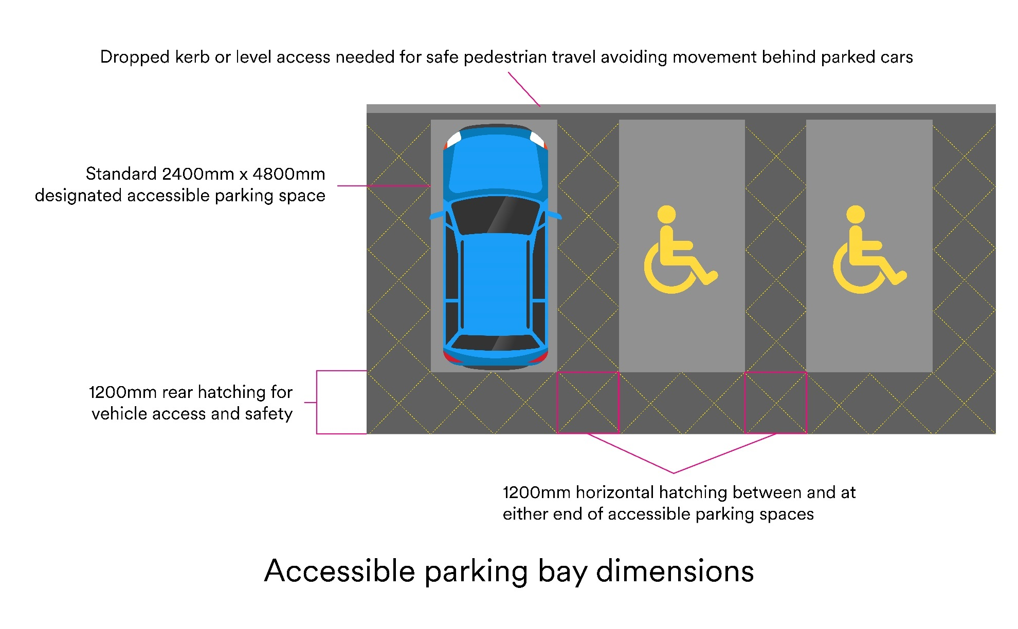

Clear widths required for different users
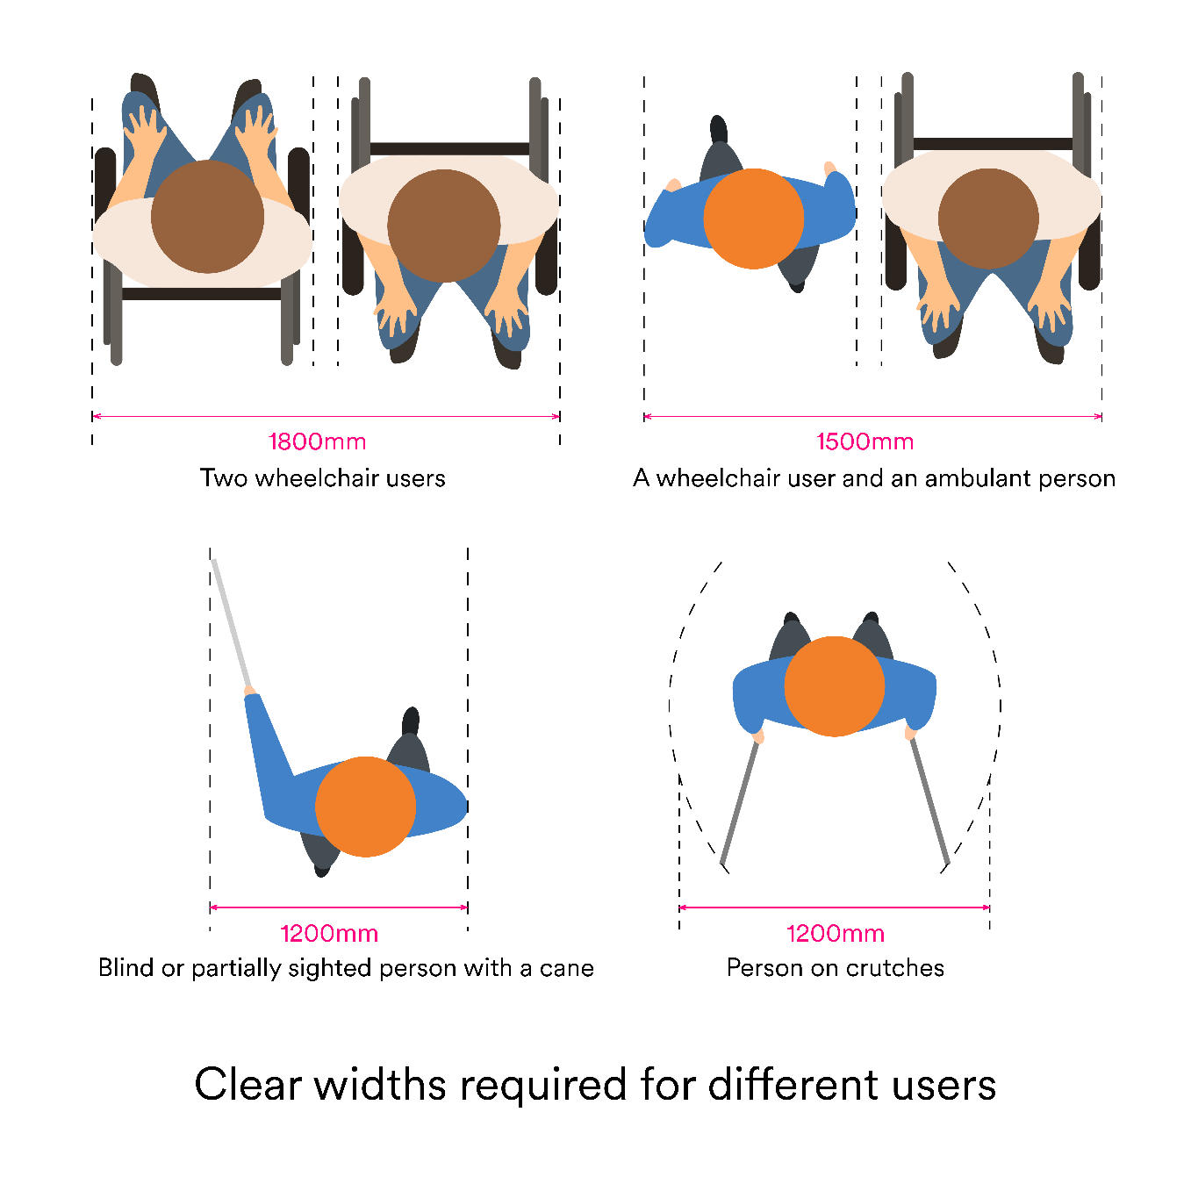

Accessible reach ranges

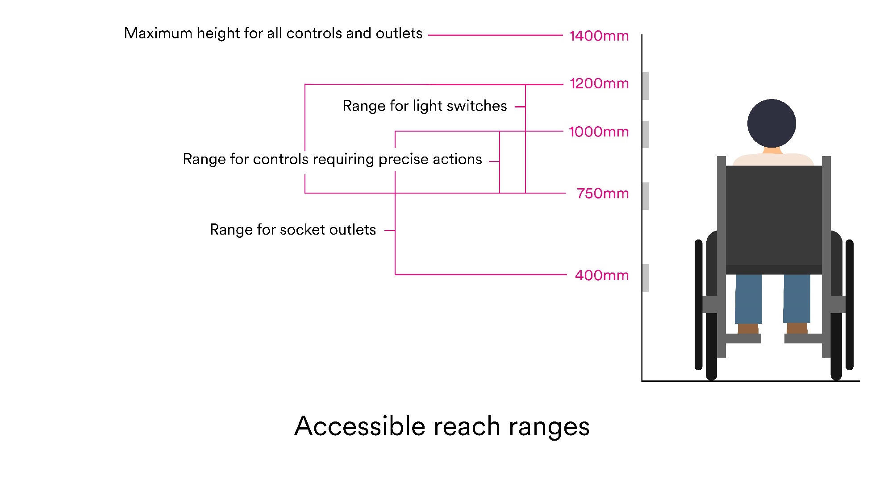

Accessible counter dimensions

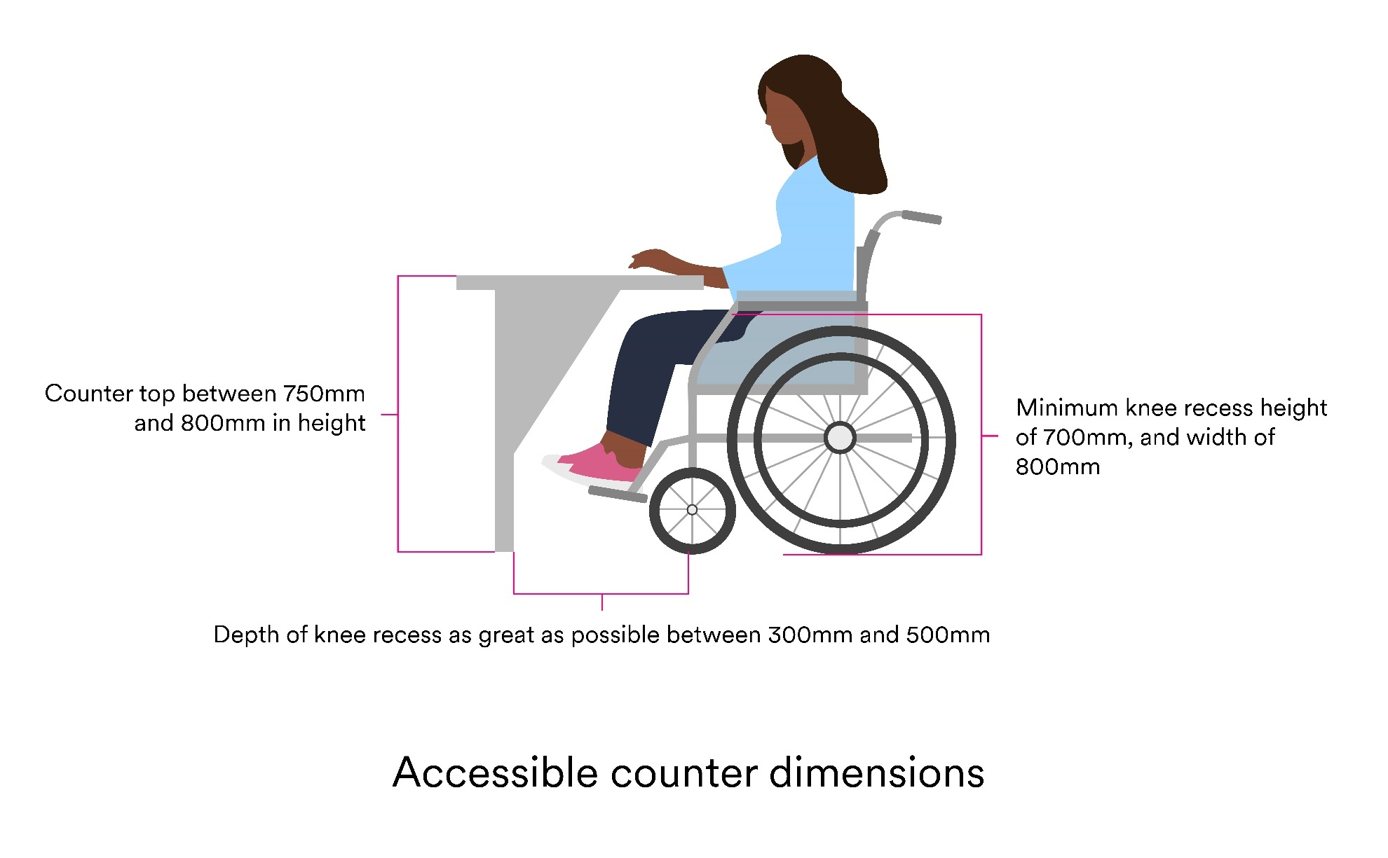

Accessible seating dimensions

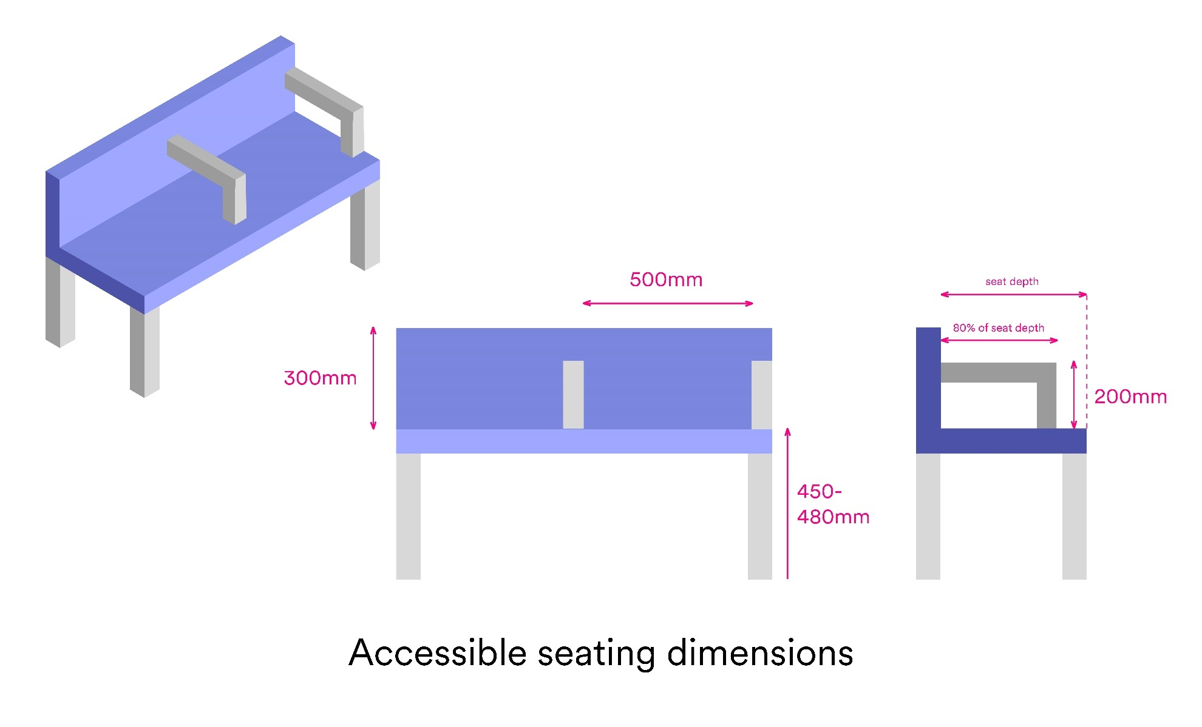

Lateral transfer space required for a wheelchair user
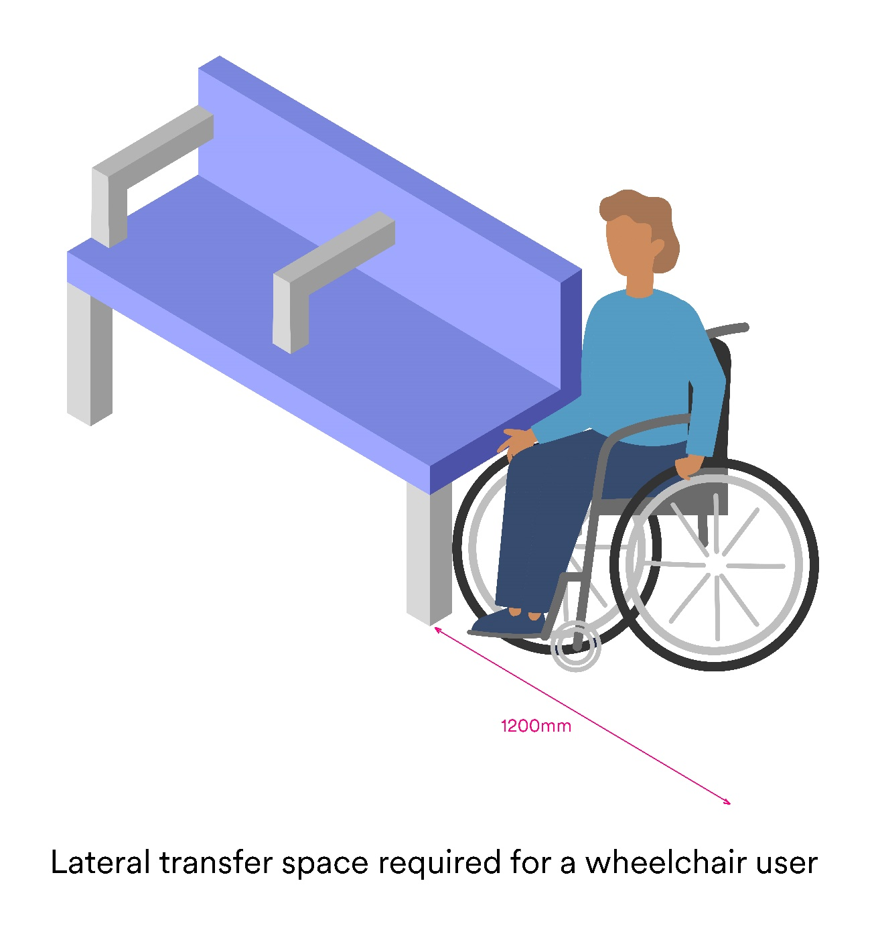

Elements within an ambulant cubicle

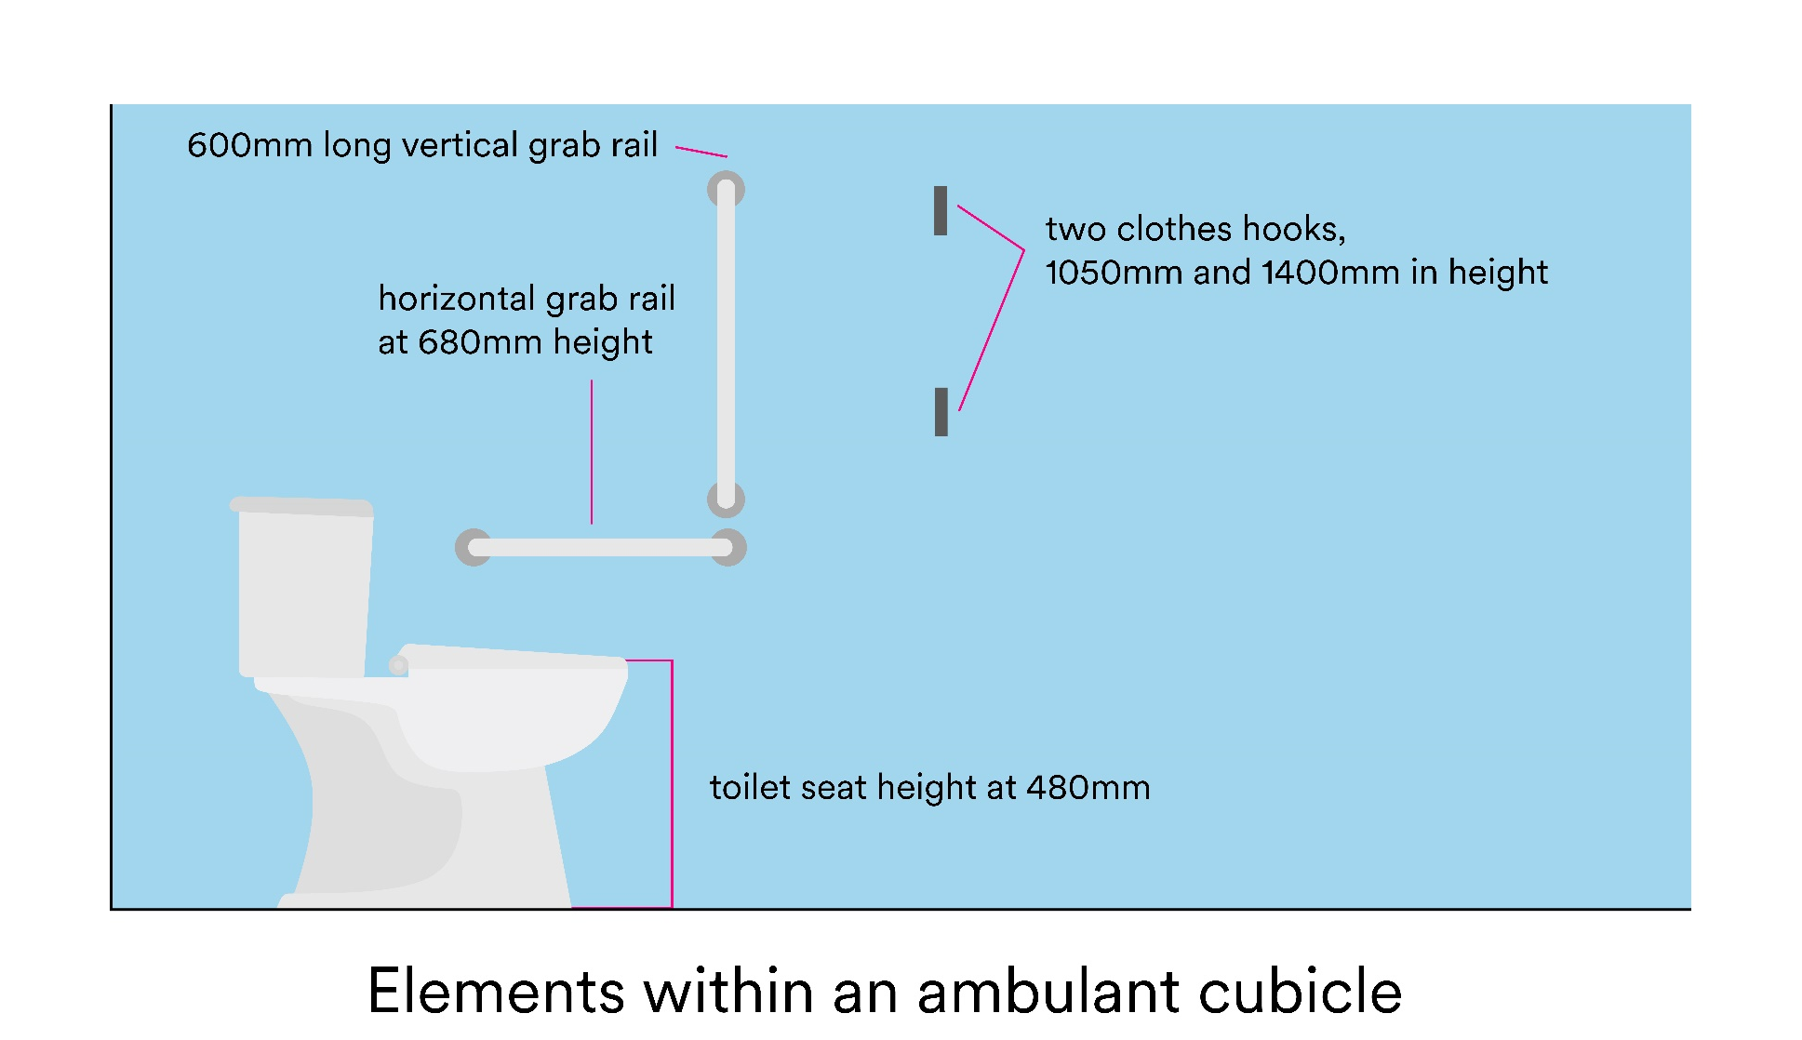

Accessible toilet dimensions
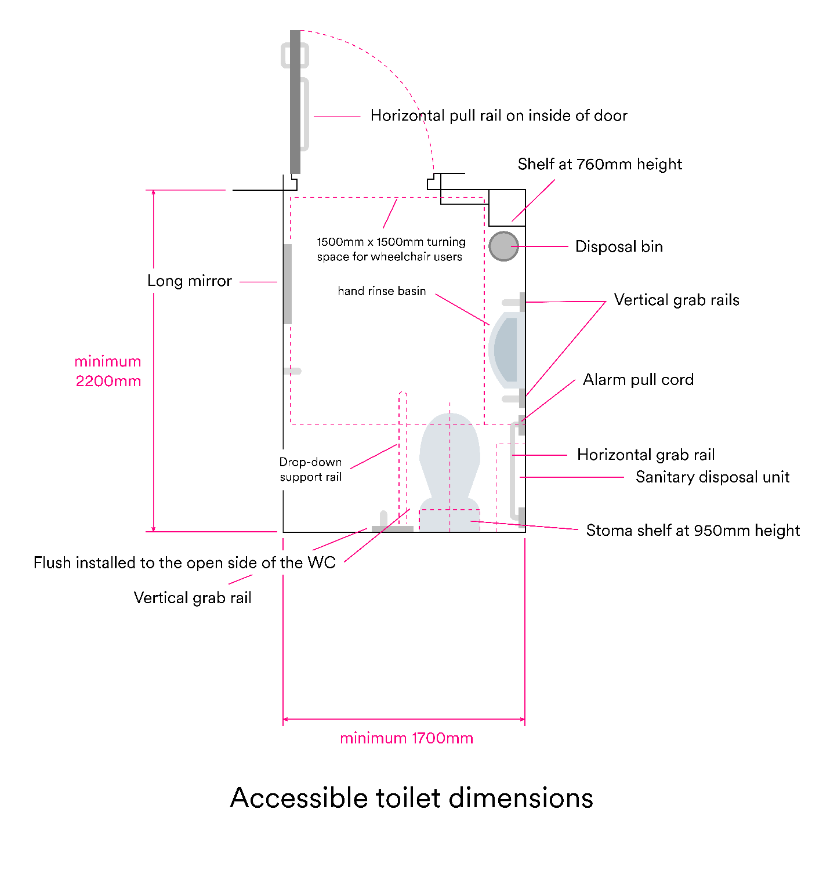

Appendix: Glossary of terms
Accessible: In terms of physical access in the built environment, something that is capable of being reached, entered or used by a particular individual. With social access, resources and training programmes, for example, need to be presented in a way that makes them accessible to all, be this in easy read format, with subtitles or by a screen reader.
Access barriers: An obstruction, preventing disabled people, or others with accessibility requirements, from using standard facilities, equipment and resources.
Access route: Any route that is used to approach a building, move between buildings or within a building.
Assistance dog relief area: A purpose-built environment, often with under-floor drainage and multiple surfaces, that allows working and assistance dogs to toilet safely and hygienically. The area must also be accessible for assistance dog owners, who often have mobility or sensory impairments.
Assistive Listening System (ALS): Technology that enables sound signals to be transmitted to people with hearing loss, without interference from background noise or excessive reverberation. Common types include induction/hearing loop, infrared, or radio transmission. Sound field systems are also used, especially in educational settings.
Braille: A system of embossed characters that enables blind and partially sighted people to read. Braille uses a combination of six dots in two vertical columns, with each combination relating to a different letter of the alphabet. Braille is not a universal, international language and is not to be confused with raised or embossed lettering.
British Sign Language (BSL): A visual language based on articulated hand gestures and their placement relative to the body. Non-manual markers such as facial expressions and movements of the body are also used. BSL is the dominant signed language in the UK. BSL is not a universal language; many other countries have their own forms of sign language.
Captioning: Text that is included with video presentations or broadcasts that enables those with hearing loss to have access to the audio portion of the material.
Changing Places Toilet: A Changing Places (CP) toilet is a room with a WC, hoist, basin, adult-sized changing bench and optional shower, for use by people with complex and multiple impairments who require the help of up to two assistants. The space needs to be fitted with a fixed tracked-hoist system so that assistants can fit the user’s slings to the hoist and move the person to the various items in the facility.
Deaf/deaf: Uppercase “Deaf” refers to a group of people who share a language (British Sign Language) and a culture. Lowercase “deaf” is used to refer to the audiological condition of not hearing.
Deaf culture: A set of values, behaviours, and traditions belonging to the deaf community and its close allies. British Deaf culture centres on the use of BSL and identification and unity with other people who are deaf.
Disability: The loss or limitation of opportunities to take part in society on an equal level with others due to social and environmental barriers.
Equality: The state of being equal, especially in status, rights, or opportunities. This also means being able to provide equal experiences and opportunities to customers and staff alike.
The Equality Act (2010): The Equality Act streamlines over 100 separate pieces of legislation to provide a legal framework that protects the rights of individuals and groups in order to advance equality of opportunity for all. It has made unjust treatment or discrimination illegal, if it is based upon one or more of nine protected characteristics: age, sex, disability, race, religion or belief, sexual orientation, marriage and civil partnership, pregnancy and maternity, and gender reassignment.
Hearing aid: A hearing aid consists of a receiver and amplifier of sound, and amplifies sounds within an environment to aid the hearing of its user. A hearing aid does not sort, process, or discriminate among sounds. Because someone is wearing a hearing aid it does not mean that the person can hear normally. Hearing aids do not correct hearing, and only amplify already distorted hearing.
Impairment: An injury, illness, or congenital condition that causes or is likely to cause a loss or difference of physiological or psychological function.
Inclusive Design: approach to the design of the environment, including buildings and their surrounding spaces, and managed and natural landscapes, to ensure that they can be accessed and used by everyone.
Inclusivity: The practice or policy of including people who might otherwise be excluded or marginalised, such as disabled people and members of minority groups.
Light Reflectance Value (LRV): Total quantity of visible light reflected by a surface at all wavelengths and directions when illuminated by a light source. The expressed difference between adjacent LRVs can aid those with visual impairments.
Manifestation: Permanent markings or features within areas with transparent glass, glazed walls, screens or doors, which help to prevent collisions by making the glazing more visible.
Neurodiversity: All types of ways humans think, move, process and act.
Neurodivergent: brain cognitive profile that functions in ways that diverge significantly from the dominant societal standards (i.e. neurotypical).
Neurotypical: Dominant types of neurocognitive function.
Quiet space: This is a dedicated space or room where sensory stimulation can be reduced in an environment which is often less visually, audibly and socially ‘busy’. Colour palettes are often neutral, soft furnishings are regularly provided, and users may have the opportunity to engage with items or activities aimed at regulating their arousal state.
Screen reader: Software used to echo text on a computer screen to audio output, often used by people who are blind, with visual impairments or with learning disabilities.
Sensory room: A sensory room is a dedicated space that contains sensory stimulating equipment. It should be an adaptive and flexible space to give the user autonomy to change elements of the environment, depending on their requirements and preferences.
Sighted guide: A sighted guide is a trained person who physically assists an individual who is blind or partially sighted, only when that person accepts assistance.
Social Model of Disability: Recognises that people are disabled by barriers in society, not by their impairment or difference. Barriers can be physical, like buildings not having accessible toilets. Or they can be caused by people's attitudes to difference, like assuming disabled people can't do certain things. The social model helps us recognise barriers that make life harder for disabled people. Removing these barriers creates equality and offers disabled people more independence, choice and control.
Tactile signage: Signs or labels with Braille, raised letters or textured patterns that can be read tactilely by visually impaired people.
Tactile paving: is a type of textured ground surface used in urban environments to assist those who are blind or partially sighted, in particular. Differing tactile patterns (such as blisters and lozenges) on the paving are used to convey distinct meanings and purposes to users, relating to both safety warnings and directional guidance.
Universal Design: is the natural evolution of Accessible Design, a design process that addresses the needs of disabled people. Universal Design goes further by taking into account the full range of human diversity, including physical, perceptual and cognitive abilities, as well as different body sizes and shapes. Everyone passes through childhood, temporary illness, injury and old age. By putting human diversity into context, Universal Design creates an environment easier for everyone to use.
Visual alarms: A flashing light that is placed into a building or alarm system to enable those with hearing loss to be alerted in an emergency.
Visual contrast: perception of a difference visually between one surface or element of a building and another by reference to their light reflectance values (LRV).
Wayfinding: Means of ensuring that someone can find their way, avoid obstacles, and know when they have reached their destination through signs, cues, landmarks and other means.
WCAG: An acronym for Web Content Accessibility Guidelines, published by the Web Accessibility Initiative of the World Wide Web Consortium, the main international standards organisation for the Internet. Websites adhering to these guidelines are considered the most inclusive.

